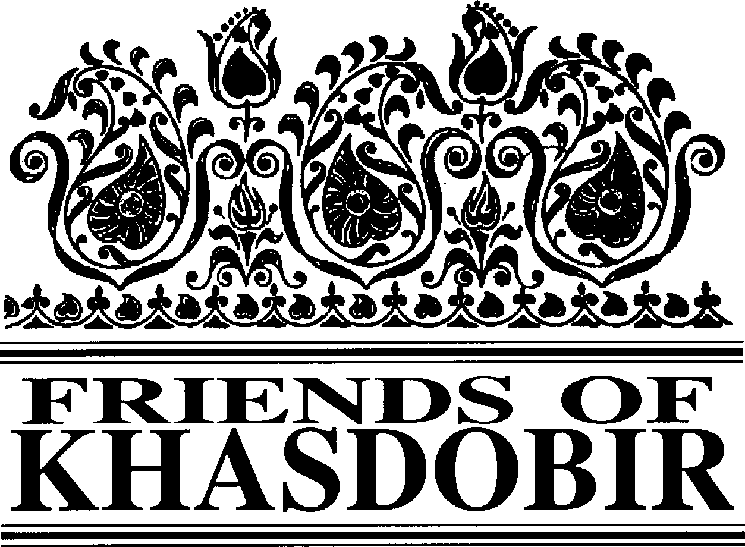
FIVE
WINTER 2019

8 Sheltered Schools Now Open Volunteers for Bangladesh Editor’s Corner
Trustees’ visit to the project Our Trip
Life on the Tea Estate
Coming up next

in this issue >>>

FRIENDS OF KHASDOBIR, BANGLADESH, Registered Charity No: 1116316
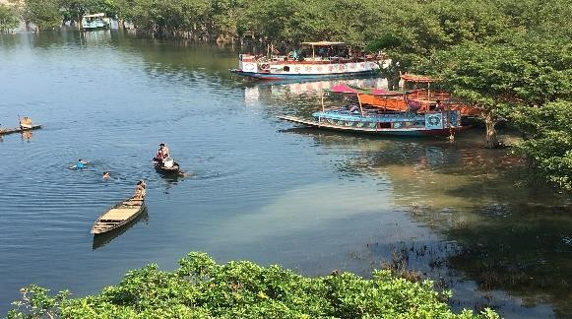
8 Sheltered Schools Now Open |  |  | Volunteers for Bangladesh
There are now 8 pre- schools meeting in rented shelters serving the Khasdobir area. Apart from the office school serving Pirmoholla, there are two schools serving the children of the tea gardens and schools serving Badambagicha, Bashbari and Boro Bazar. All the schools have electricity and access to a toilet and washing facilities for the children. There are 30+ children attending each school.
All the teachers took part in 3 days of training at the end of December. Each teacher was provided with a book with teaching techniques for use with the children. At the end of the training the teachers were so enthusiastic about what they had learnt that they proposed extending the school day by an extra half hour so that they could make good use of all the games, stories and songs they had learnt to use during the training.
At the end of December some of the children from each school transferred to local primary schools and we hope to follow their progress in the future.
Early in our visit we met volunteer leaders of the Sylhet division of Volunteers for
Bangladesh (http://vbd.com.bd). This is a young people / students’ branch of the Jaago Foundation and calls to young people to help to ‘Rebuild our Nation’. We had just visited Badambagisha school and noticed that a small side room would be really useful if
it was cleared up and painted.
So in our meeting we asked if VfB might be able to do such painting. They were very keen and a few days later (everything seems to happen straight away in Bangladesh!) they were working with a professional decorator on the little side room, the main room and also on the school room in the office – much more that we had originally imagined. The volunteers painted cartoon characters, handprints, letters, numbers and trees with great enthusiasm.
The children and teachers were very pleased with the results and Volunteers for
Bangladesh appeared to be happy to be linked with us and to be approached in future for further voluntary activity.
Chairman Mike Sherriff
Treasurer Kazi Mashud,
208, Leicester Road, Loughborough, Leicestershire, LE11 2AH
Newsletter Editor Monjur Elahi, 47 Chart Downs,
Dorking, Surrey, RH5 4DF Email: monjurelahi@msn.com
Patrons: The Rt Hon Nicki Morgan MP; Sir Kevin Barron MP
Web Site www.khasdobir.org.uk

Meeting of Trustees took place at 11.30am, Saturday 12th January 2019, Bangladesh Social Association, Loughborough. Some extracts from the meeting is
provided below.

As we have recently changed the organisation who deliver our project a strong emphasis of our visit was to get to know the Sylhet Jubo Academy and the people behind the name.

Enim ad minimeniam, quis
erat nostr uexeFrcuintadtiRonaising ullamcorper nostru exerci
There have been two significant donations recently. tation ullam corper et
£500 was given in memory of Sumon Momen and iusto odio dig nissim qui
Trinity URC raised £665. Trustees expressed their blandit praesent lupta.
gratitude for these wonderful contributions to the work in Khasdobir.

Constitution:

A draft proposal had been circulated to Trustees. Under this model Trustees would appoint new Trustees rather than taking proposals to the AGM. The meeting was in favour of this approach.
Sue Simmons and myself, Maureen
Haddock made the Trustee visit to Bangladesh in October 2018. Mike Sheriff, Chair of Friends of Khasdobir was already in Sylhet so we joined him at our normal hotel. Mike had sent us a very full itinerary which covered every aspect of our project. Early in the visit schedule we visited the Sylhet Jubo Academy (SJA)
n office in Sylhet and had a meeting with
issim qui blandit praesent lupta. Tummer
elenit augue duis dolore te feugait nulla acilisi. Con erattis sectetuer adip iscing elit, ed erat diam nonummy nibh magna erat liquam erat volutpat. Nam liber tempor
um soluta nobis sed diam nonummy.
d Faisal Ahmed, the Executive Director and
f Sabiha Sultana (the project manager for
s
a the Khasdobir project). We also met
c Joynal Abedin who is the accountant for
our project. We were shown the accounting processes and records and were very impressed with their thoroughness, cross referencing and
Later we met, over dinner, members of the governing body of SJA. They demonstrated an interest in the Khasdobir project and hoped to visit in the near future.
In addition to our work with SJA we visited all the schools currently up and running and were very pleased to see the teacher and teaching assistants hard at work. All the children have lovely books and resources which are kept in a metal lockable boxes which contain books, pencils, crayons etc. A key emphasis in choosing suitable sites for our schools is that they must be covered (so the children can attend during the rainy period) and that they have toilet and
hand washing facilities.

Shelterd
Support for the widows continue s
apparent accuracy.
We briefly scrutinised the SJA
comprehensive
policy folder which
It was clear that the SJA team were pleased to be working with Friends of Khasdobir and were committed to providing the elements of our project to a high standard.
Although some of
the buildings are not ideal, we are very pleased that all the schools meet these criteria.

schools in

contained details of policies on human resources, financial management, fraud and corruption, IT, child protection, gender, transport and travel, and operational systems.
All of these policies are applicable to the staff of the Khasdobir project. (These polices are available on the SJA website as are many photographs of their projects http://www.sjabd.org )
The project office is a very nice spacious
building which houses the sewing class (which is thriving and growing in numbers) the computer classes, and one of the schools. The building is also used for meetings and administration.
At the end of our visit we were able to make a list of recommendations for both SJA and Friends of Khasdobir all of which focus on the sustainability and further development of our project.

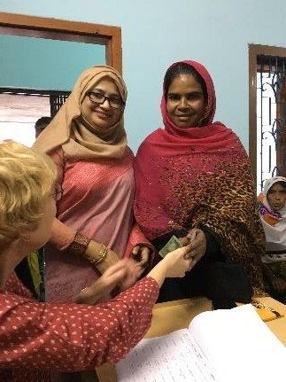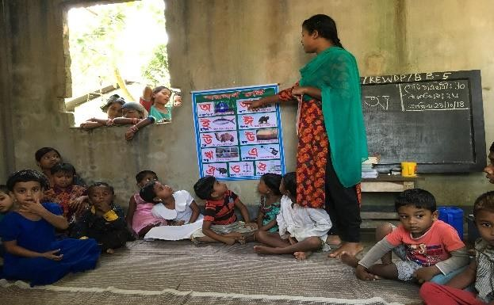
set the stage >>>
Stay with us, Support us!
We are compliant to EU General Data Protection Regulations

Do you receive the newsletter by post now and would you be happy to receive it by email?
Also notify us if you no longer wish to receive the newsletter (by either post or email).

Please email to khasdobir@btinternet.com

Thank you for using www.freepdfconvert.com service!

Only two pages are converted. Please Sign Up to convert all pages. https://www.freepdfconvert.com/membership

