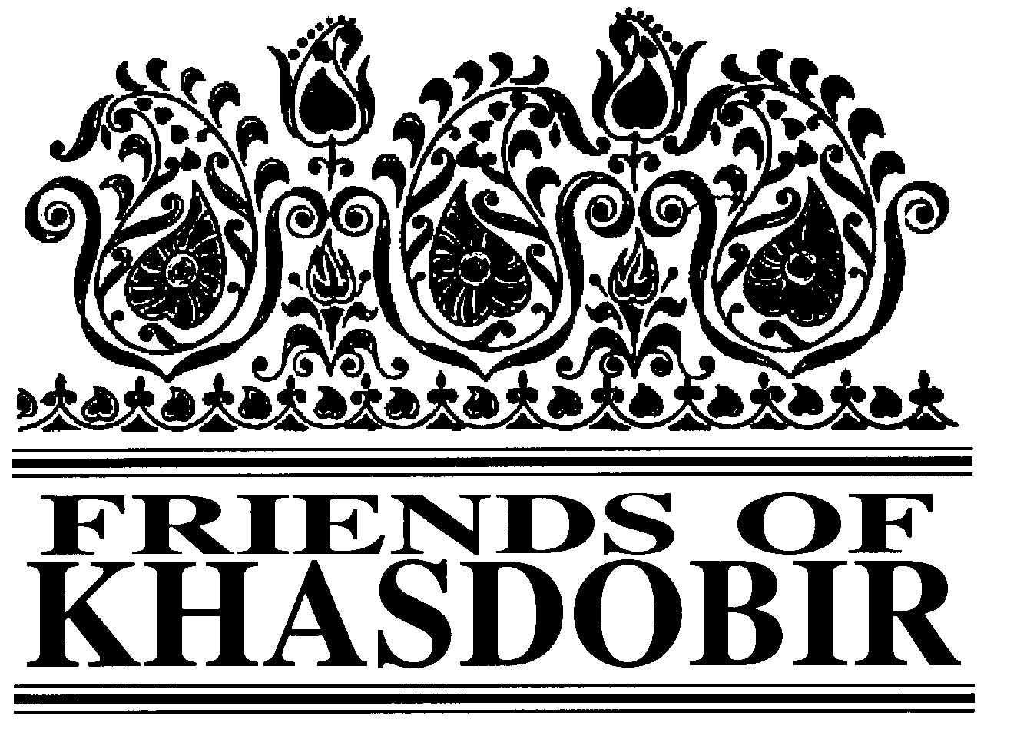
FRIENDS OF KHASDOBIR, BANGLADESH
Registered Charity No: 1116316
NEWSLETTER
WINTER 2018
Our First Schoolroom Opens Named for Peter East

The first covered space for our schools has now been constructed and named after one of the founders of KYAG, Peter East.

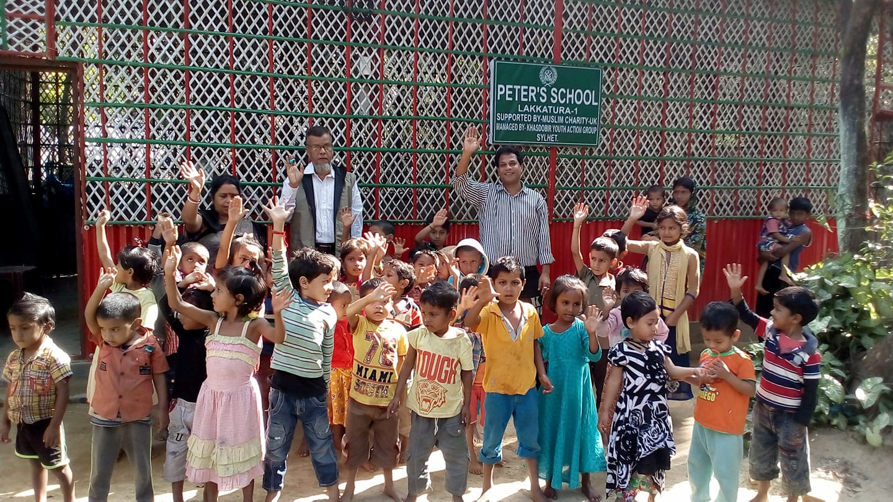
Peter’s school is a simple construction of iron sheet and bamboo. It has been built for one of our schools on the tea estates. Alongside the school room is a tube well and a lavatory. Muslim Charity UK generously provided
the funds for the school room and Sylhet Jubo Academy managed the construction. We are very grateful for all their help.

The new facility, which includes a fan and electric lighting, means that the school can continue to meet during the rainy weather. This was the main improvement that parents and guardians suggested during
meetings with our chairperson, Mike Sherriff, and KYAG Monitoring Officer, Afzal Rahman. As well as running a school for the young children we hope that the room can also be used for coaching and training, including computer training.

Negotiations have now started to find sites for more shelters. We hope to start work on a second shelter on the tea estates early in the New Year. Finding sites to serve the children from the slum areas in the city is proving more difficult.

We welcome donations from our supporters towards this
development. Each
shelter costs
approximately £6,000, depending on the conditions on the site.

Chairman Mike Sherriff
Treasurer Geoffrey Pool, 7 Stoneygate, Leicester LE2 2BL
Newsletter Editor Ken Prideaux-Brune, 13 Hollybush Lane, Amersham,
Bucks. HP6 6EB. Tel: 01494 433871. Email: pbrune@olcs.net President KYAG Kabir Ahmed, KYAG, PO Box 118, 3100 Sylhet, Bangladesh Patrons: The Rt Hon Nicki Morgan MP; Sir Kevin Barron MP
Web Site www.khasdobir.org.uk
Supporting

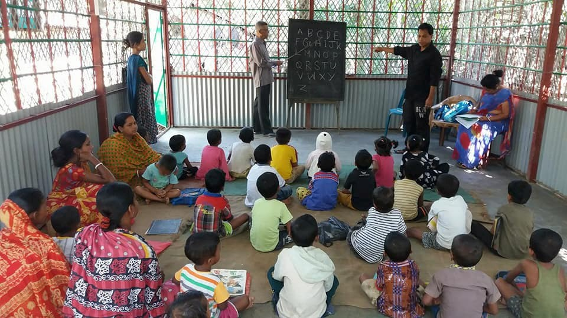

Children at the Peter East School under the Sky enjoy their lessons sheltered from rain and sun in the newly built shelter (see page 1).

Successful concert
A Concert was held in December at Trinity Methodist Church, Loughborough. Three
excellent choirs - Loughborough Male Voice Choir, The Three Churches Choir, and the Carolyn Sharpe Singers all took part, as well as
Chris Hill Jazz. It was a lively and very enjoyable evening with a large attendance and raised
£620 for the Friends of Khasdobir.

Our AGM
Saturday June 30
11.30 am
At Rosebury St Peter’s Community Centre Storer Road Loughborough
LE11 5EQ

Do make a note of the date and come if you possibly can.
This Year’s London Walk
There will be another sponsored walk for Friends of Khasdobir this September and it will explore Fitzrovia and Marylebone, starting from the School of Tropical Medicine. These walks provide an opportunity to explore the history of an area of London, with the aid of a specially produced booklet, and to meet other supporters of the project. Don’t miss this opportunity if you are within reach of London. Either gain sponsorship for Friends of Khasdobir and walk for free or just walk for fun in return for a small payment.

The Walk has proved a very significant fundraiser for the Friends so do please support it if you can. Details of how to register and where to report to start the walk next time.

Saturday September 1

Introducing Computers to Coaching Class Students

As mobile phones come down in price and more jobs require people to be able to use a computer learning about computers has become something of great interest to the KYAG coaching class students. The opportunity to attend a workshop introducing the coaching class students to basic computing skills was therefore very welcome.

The computing workshop

was run by Computers Are Free For Everyone (CAFFE). This is a small UK charity running computer classes for people unable to afford them in Bangladesh. It was set up by a former Voluntary Service Overseas (VSO) volunteer who used to work in Sylhet.

Despite the heavy rain all the coaching class students who had booked
to come set off together in six small 3 wheeler taxis to the CAFFE centre in Sylhet. The workshops included a basic introduction to computers, graphics and engineering. Our students were introduced to the basics of coding and design for work with computers. CAFFE also attended one of the coaching class sessions and did some more work with our students using laptops that they brought along.

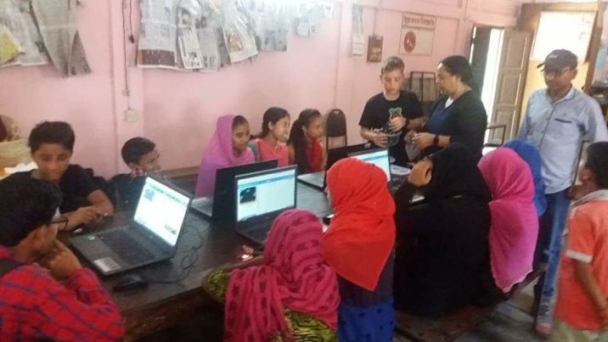
They have offered to run regular sessions for our students and we aim to start these early in the New Year.

One laptop has already been donated and we hope to raise funds for more laptops that can be used by our students on a regular basis.

Working With Parents
The main concern by parents at all schools has been the lack of a shelter

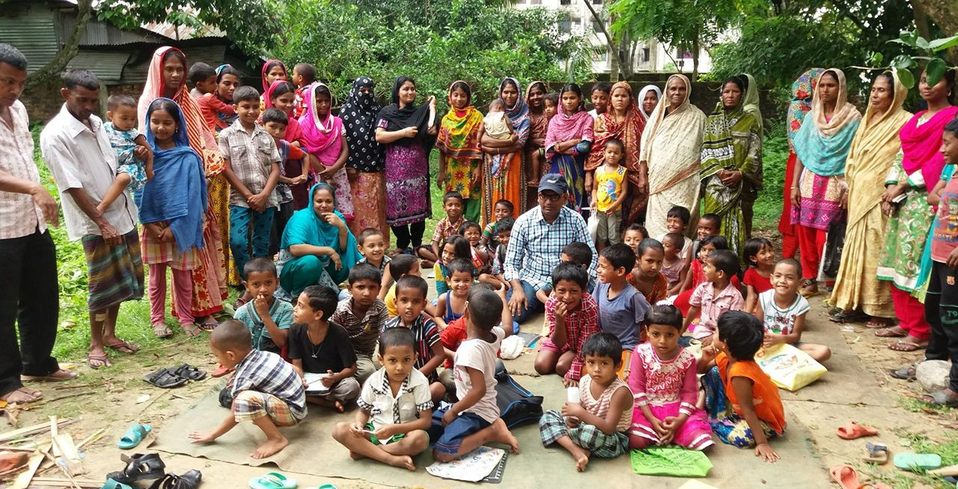
KYAG has recently developed a new initiative to work with the parents and guardians of children attending the schools under the sky. The aim is to motivate the parents to encourage regular attendance by the children and to support them so that they can encourage and support their children’s education. At each school a meeting of parents is held two or three times a year. So far there has been at least one meeting at
each school. The parents and guardians are encouraged to give their opinion about the schools.
when it rains and when the sun is very hot. This sometimes means that schools cannot meet.

YES, I’d like to help...

Title Forename(s) Surname:

Address

Post code

Please complete either Section A or B and if you are a UK taxpayer and have not already done so please sign the Gift Aid form in Section C, making each pound you contribute worth an additional 25p. Then send this page to:
Geoffrey Pool, 7 St John’s Road, Stoneygate, Leicester LE2 2BL

A - by Cheque (payable to Friends of Khasdobir). I enclose my contribution of £...............

B – by Banker’s Order
To: ……………………………………………….
(Name of Bank)
……………………………………………………

……………………………………………………

……………………………………………………
(Address of bank)

Please pay to:
Friends of Khasdobir. At Barclays Bank, Town Hall Square, Leicester, Branch. Sort Code: 20 49 17. Account no: 20587192

The sum of £………… on …… ……………20……..
And thereafter the same amount on the same day each month until further notice.

………………………..………………(Signature)

…….…………….(date)

.............. .…………………………….(Account No.)

C – Gift Aid
I am a UK taxpayer and would like Friends of Khasdobir to reclaim the tax I have paid on any donations I make to them.

Signed ………………………………….

Date ……………………………

Notes:

This declaration is in force from the above date until it is cancelled. It need only be made once.

You must pay in tax (income tax and capital gains tax added together), at least the total of all donations that you make to charities each year. The donation that you make to the Friends of Khasdobir, Bangladesh is included in this total.

If your financial circumstances change, and you cease to pay income tax or capital gains tax at a level at least equal to the sum that you donate to all charities each year, then please let Friends of Khasdobir know by writing to the Treasurer.

