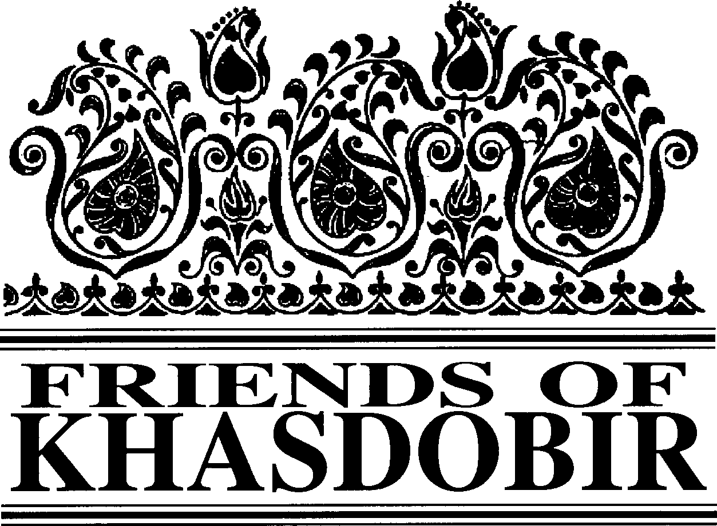
Friends of Khasdobir, Bangladesh
Charity Number 1116316

12th Annual Report and Accounts
To 31st March 2019
Patrons: The Rt Hon Nicky Morgan MP, Sir Kevin Barron MP

Trustees

Mr Mike Sherriff (Chair)
Mrs Moyra Blake (Vice-Chair) Ms Maureen Haddock
Mrs Kathleen Jackson
Mr Kazi Mashud (Treasurer) Mr Monjur Elahi (Mithu)
Bankers: Barclays Business Banking.
Ind. Examiner: ICFS Agar FCA
Web site: www.khasdobir.org.uk.
Of an

((

Mr Geoffrey Pool Ms Sue Simmons Mrs Doreen Watson
Mr Philip Watson (Secretary)

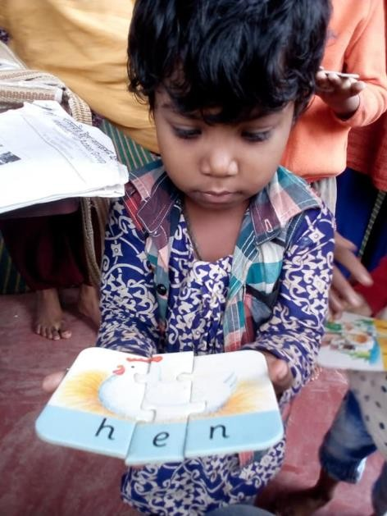another, are elected annually at the Annual General Meeting.
History and Objectives
Friends of Khasdobir came into existence at our
inaugural meeting on July
8th
2006 and our
registration as a charity was completed in October 2006. For several years prior to that we operated as part of Toc H under the name Toc H Friends of Khasdobir. The objects of Friends of Khasdobir, Bangladesh are:

To advance the education of children, young people and adults in Bangladesh, in particular by supporting the work of the Khasdobir Youth Action Group to provide and assist in the provision of facilities for education in the area currently known as Sylhet.

The relief of financial hardship among people living in Bangladesh, in particular by supporting the work of the Khasdobir Youth Action Group to make grants of money and provide goods, services or facilities for the relief of the poor living in the area currently known as Sylhet.

To advance the education of the public in England and Wales on the subject of development in Bangladesh.

Structure, Governance and Management
The Charity is governed by a Constitution adopted at a General Meeting held on July 8th 2006. Trustees, most of whom have visited the project we support in Bangladesh at one time or

Review of the Year

Friends of Khasdobir supports the educational and welfare work begun by Peter East and Harun Ahmed in Sylhet, Bangladesh, a project started some 35 years ago.

Inevitably in the last 35 years there have been significant changes in the Khasdobir area and from 1st July 2018 the Friends supported the Sylhet Jubo Academy to deliver the project in order to introduce much needed changes to its management

Continued on page 2

Continued from page 1

and working practices. The emphasis this year has been on improving the quality of the pre-school education. Some of the long serving teachers on the project have been joined by new teachers. All the teachers undertook a 3-day training programme in December. All the schools now have a shelter, enabling them to continue during rainy weather and to make use of teaching resources that it was not possible to use in an open setting. There are now 3 schools serving children on the tea estates, from some of the poorest families in Bangladesh. We also have schools serving children living in the slum areas on the outskirts of Sylhet and a small outreach team who are assisting children with disabilities to get extra support and helping families whose children do not have a birth certificate to get one, so that they can gain admission to government primary schools.

In addition to the work with pre-school children the sewing class continues to be successful. From the current batch of 40 students 10 are already earning money using the new skills they have acquired. In collaboration with Computers Are Free for Everybody we have also been running computer training at the Project Office, and again the emphasis is on helping the young people to acquire skills which they can use to earn some money from on-line freelance work.

The Project currently provides allowances to 70 widows and in March the circumstances of all the widows were reviewed. In several cases these have changed, as the widow’s dependent children have grown older and able to support themselves and their widowed mothers. All the widows are now being offered the opportunity to join sewing training classes. In the forthcoming year some new widows living in the area will receive an allowance - especially those who are very frail or have dependent children to support.

In October two of our trustees, Sue and Maureen, visited the project. Highlights included an initiative with young people who are part of Volunteers for Bangladesh.

Murals with cartoon characters were painted on the walls of two of the schools. There was also an outing with the computer class students to one of the beauty spots in Sylhet.

It is the intention of Friends of Khasdobir to fund the Sylhet Jubo Academy for the next 3 years to deliver the project, giving more emphasis to reaching the most vulnerable people living in the area and providing them with pre-primary education, training relevant to future opportunities to earn a living and support for those widows with greatest need.

This year we have been particularly grateful to the churches in the Thirsk and Northallerton Methodist Circuit, who adopted the Friends of Khasdobir as their charity of the year. In total they raised £7,555 which was a big boost to our fundraising. We also continued to raise funds from the annual sponsored walk and fundraising meals. We thank everyone concerned for the generosity and hard work that has contributed to our fundraising. Fundraising is a continuous challenge for small charities, and we appeal to all our supporters to consider how they may assist us with this important work in the future.

This year, at our AGM, the trustees will be proposing that we become a Charitable Incorporated Organisation. This is a new form of charitable constitution that limits the liability of trustees. Its adoption should also assist us in the process of recruiting new trustees.

Thank you to everyone who has donated to us and supported us during the past year. We look forward to your support during the coming year to make a real difference to the lives of people living in need in the Khasdobir area, and continuing the work begun by Peter East and Harun Ahmed many years ago.

Risk Assessment
The Trustees have considered the risks to which they may be exposed and have policies in place to manage these to an acceptable level.

Continued on page 3

2

Continued from page 2
These accounts will be presented at our AGM on
Saturday June 29th
11.30 am
Rosebery St Peter’s Community Centre,
Storer Road, Loughborough LE11 5EQ
This is your opportunity to learn more about the developments taking place at the project and to support the Trustees.
So that we know numbers for the curry lunch please phone or email Kathleen Jackson (01509 557740 – derkat.46@ntlworld.com.) by June 16th to let her know you are coming.

Public Benefit
The Trustees confirm that due regard has been given to the Charity Commissioners’ guidance on public benefit issued in February 2014. The work in Bangladesh, which we support, assists the very poorest people in the area without charge. Through the newsletter sent to donors and through the fundraising meals Friends of Khasdobir educates citizens of the UK about the problems faced by poor people in Bangladesh. The Trustees are confident that they provide public benefit.
For more news and pictures do please visit our website:
www.khasdobir.org.uk

The statement below is that normally provided by the external examiner after he has examined the accounts to make sure that there is nothing that needs further examination. This has not been possible so far this year, so the accounts are unexamined. The accounts will be sent to him for examination as soon as is possible.
Independent Examiner’s Report to the Trustees on the unaudited financial statement of Friends of Khasdobir, Bangladesh (on Page 4)
I report on the accounts of Friends of Khasdobir, Bangladesh, to 31st March 2019.
Respective responsibilities of Trustees and Examiner

As the charity's trustees you are responsible for the preparation of the accounts, you consider that the audit requirement of section 144(2) of the Charities Act 2011 (the Act) does not apply and that an independent examination is needed. It is my responsibility to examine the accounts under section 145 of the Act, to follow the procedures laid down in the General Directions given by the Charity Commission under section 145(5)(b) of the Act, and to state whether particular matters have come to my attention.
Basis of Independent Examiner’s Statement

My examination was carried out in accordance with the general Directions given by the Charity Commission. An examination includes a review of the accounting records kept by the charity and a comparison of the accounts presented with those records. It also includes consideration of any unusual items or disclosures in the accounts, and seeking explanations from you as trustees concerning any such matters. The procedures undertaken do not provide all the evidence that would be required in an audit and consequently no opinion is given as to whether the accounts present a “true and fair view” and the report is limited to those matters set out in the statement below
In connection with my examination, no matter has come to my attention:
- which gives me reasonable cause to believe that in any material respect the requirements:
  - to keep proper accounting records in accordance with section 130 of the Act; and
  - to prepare accounts which accord with the accounting records and to comply with the accounting requirements of the Act
have not been met; or
- to which, in my opinion, attention should be drawn in order to enable a proper understanding of the accounts to be reached.

ICFS Agar FCA
FRIENDS OF KHASDOBIR: BANGLADESH Charity No. 1116316
3
Robert Whowell & Partners
CHARTERED ACCOUNTANTS AND STATUTORY AUDITORS
78 Loughborough Road, Quorn, Leicestershire, LE12 8DX

Accounts for the Year 1st April, 2018 to 31st March, 2019
 | Present Year | Last Full Year | Last Full Year
 | from  01/04/2018 | to  31/03/2018 | to  31/03/2017
to
31/03/2019
RECEIPTS | £ | £ | £
Donations from Individuals: Gift Aid Tax Recoverable | 14,229.30 | 15,836 | 22,223
Donations from Individuals: Gift Aid Tax Not Recoverable | 3,633.78 | 17,243 | 14,652
Fundraising Meals Income: Gift Aid Tax Recoverable | 2,931.00 | 4,439 | 3,749
Fundraising Meals Income: Gift Aid Tax Not Recoverable | 243.00 | 531 | 447
Donations From Individuals on The London Walk: Gift Aid Tax  Recoverable | 876.34 | 688 | 757
Donations From Individuals on The London Walk: Gift Aid Tax  Not Recoverable | 35.00 | 1,062 | 81
Donations from Groups, Toc H Branches and Other Organisations | 4,923.35 | 6,166 | 826
Legacies | 0.00 | 0 | 2,000
Sales of Calendars, Surplus Jewellery, and Other Items | 0.00 | 0 | 30
Interest from Charities Official Investment Fund (COIF) Deposit  Account | 35.91 | 9 | 29
Interest from Charities Official Investment Fund (COIF)  Investment Account | 7,282.98 | 7,423 | 7,385
Tax Recovered from HMR&C on Previous Year's Gift Aidable Donations | 4,980.45 | 6,352 | 4,579
TOTAL RECEIPTS | 39,171.11 | 59,748 | 56,758
PAYMENTS
Final Grant to KYAG (£2000.00) & then to Sylhet Jubo Academy in Bangladesh | 34,077.00 | 47,999 | 51,000
New Colour Leaflet about Project | 0.00 | 0 | 0
Quarterly Newsletter Printing and Packing | 60.00 | 553 | 288
Postage (Mainly Newsletters, but Other Letters also) | 81.36 | 563 | 532
Meeting Room Hire | 19.00 | 97 | 83
Project Expenses by Trustees for Khasdobir Work | 2,118.00 | 0 | 0
Website Registration, Design, Management and Server Provider  Continuation | 0.00 | 0 | 0
Trustee(s) Monitoring Visits to Bangladesh | 9,383.34 | 0 | 500
Transport Costs for Computer Class Staff | 394.00 | 0 | 0
Grant to Sylhet Jubo Academy for Shelter Construction | 5,361.00 | 0 | 5,995
Expenses Incurred by the Chairperson | 0.00 | 0 | 25
Public and Trustee Liability Insurance | 191.88 | 0 | 0
Bank Charges for Transferring Money to KYAG's & then SJA's Account in Sylhet | 177.00 | 100 | 125
TOTAL PAYMENTS | 51,862.58 | 49,312 | 58,547
Surplus ( - = Deficit) | -12,691.47 | 10,436 | -1,789

4

BALANCES
Balance Brought Forward From Previous Year, Incorporating Investment Account | 229,864.83 | 215,225 | 1,888,935
Valuation as at 1st April, 2018
Surplus or Deficit This Year | -12,691.47 | 10,436 | -1,789
Cumulative Surplus Carried Forward | 217,173.36 | 225,661 | 187,146
Represented By:
Barclays Bank Current Account | 2,273.24 | 22,078 | 2,124
CCLA Charities Official Investment Fund (Deposit) Account | 9,087.92 | 1,748 | 1,776
CCLA Investment Fund as at 1st April, 2018 | 205,812.20 | 201,835 | 183,256
Total Bank Balances | 217,173.36 | 225,661 | 187,146
Note: The CCLA Investment Fund balance was £222, 052.72 on 31st March, 2019.

Friends of Khasdobir Annual Report and Accounts adopted By the Trustees on 29th June 2019

MIKE SHERRIFF Kazi Mashud
Chair of Trustees Hon Treasurer

5

