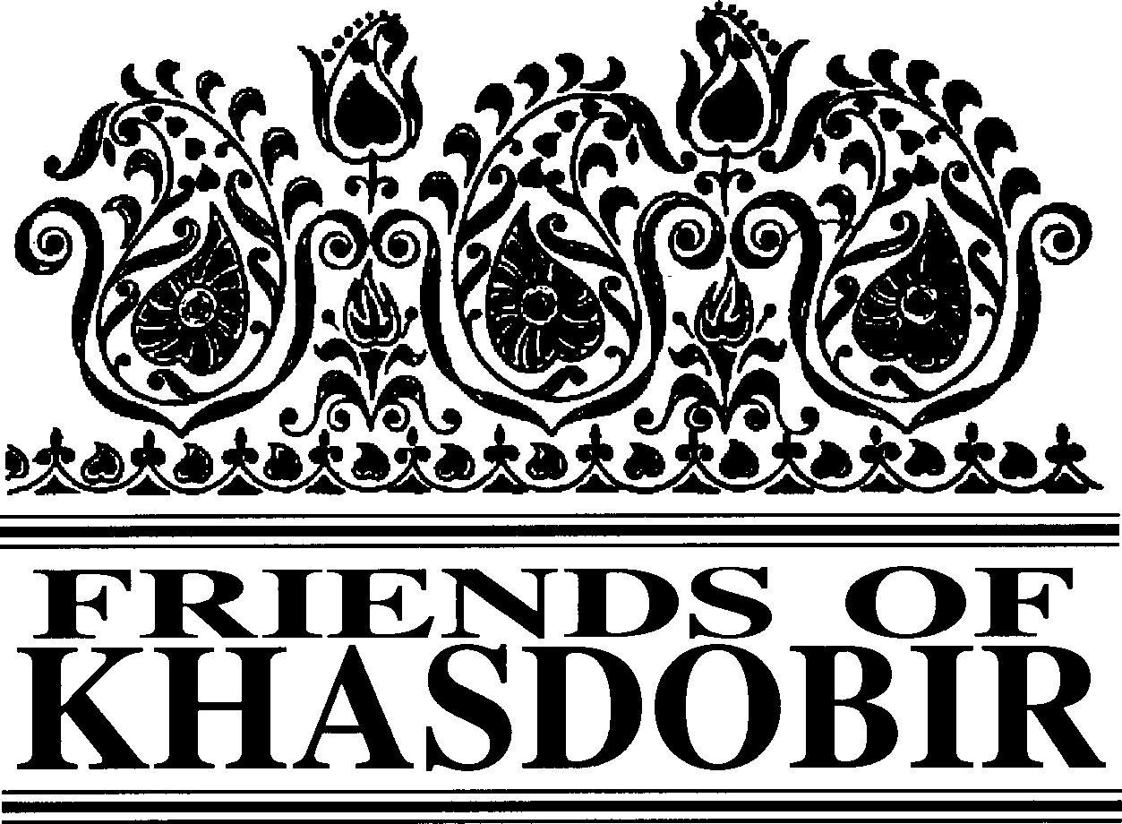
Friends of Khasdobir, Bangladesh
Charity Number 1116316

12th Annual Report and Accounts
To 31st March 2018
Patrons: The Rt Hon Nicky Morgan MP, Sir Kevin Barron MP

Trustees

Mr Mike Sherriff (Chair) Mrs Moyra Blake
Mrs Jean Brown
Ms Maureen Haddock Mrs Kathleen Jackson Mr Kazi Mashud
Bankers: Barclays Business Banking.
Ind. Examiner: ICFS Agar FCA
Web site: www.khasdobir.org.uk.
Of an

Mr Monjur Elahi (Mithu)
Mr Geoffrey Pool (Treasurer) Ms Sue Simmons
Mrs Doreen Watson
Mr Philip Watson (Secretary)
History and Objectives
Friends of Khasdobir came into existence at our
inaugural meeting on July
8th
2006 and our
registration as a charity was completed in October 2006. For several years prior to that we operated as part of Toc H under the name Toc H Friends of Khasdobir. The objects of Friends of Khasdobir, Bangladesh are:

To advance the education of children, young people and adults in Bangladesh, in particular by supporting the work of the Khasdobir Youth Action Group to provide and assist in the provision of facilities for education in the area currently known as Sylhet.

The relief of financial hardship among people living in Bangladesh, in particular by supporting the work of the Khasdobir Youth Action Group to make grants of money and provide goods, services or facilities for the relief of the poor living in the area currently known as Sylhet.

To advance the education of the public in England and Wales in the subject of development in Bangladesh.

Structure, Governance and Management
The Charity is governed by a Constitution adopted at a General Meeting held on July 8th 2006. Trustees, most of whom have visited the project we support in Bangladesh at one time or
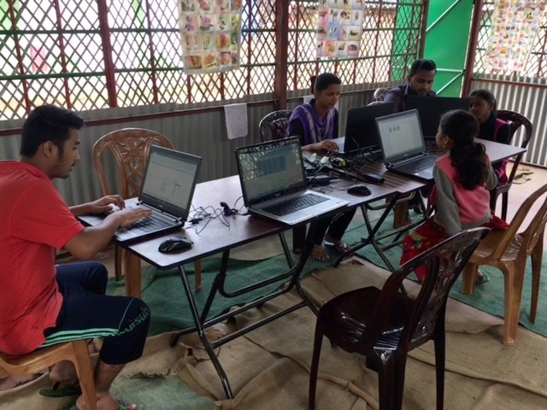
A computer class in KYAG’s first shelter on the Lakhatoorah tea estate.

another, are elected annually at the Annual General Meeting.

Review of the Year
Friends of Khasdobir supports the educational and welfare work begun by Peter East and Harun Ahmed in Sylhet, Bangladesh, a project started some 34 years ago. Inevitably in all that time there have been significant demographic and other changes in Sylhet. Both the birth rate and the illiteracy rate have sharply declined and there is now increased provision for pre-school education. Access to mobile phones and the internet is now common, even amongst the poorest people living in the area.

Continued on page 2

Continued from page 1

Trustees recognise that they have a responsibility to ensure that charitable funds sent to Bangladesh are used effectively for the purposes for which they were donated. Mike Sherriff, who chairs Friends of Khasdobir (and speaks Bengali) has made 4 extended visits to Bangladesh since October 2016 and he and another Trustee, who visited the project on behalf of the Trustees in March 2018, have been exploring ways of ensuring that the project continues to meet contemporary needs while retaining the ethos with which it was endowed from the start.

The number of children attending KYAG’s open air schools has steadily declined because of the decreasing birth rate and development of alternative provision. An obvious problem with open air schools is that they can’t operate on rainy days and so the aim is to find sites on which simple shelters can be erected. One building has already been provided and work at a second site has recently started. The shelters will be made available for other educational activities – the existing building is already being used for computer classes provided by Computers Are For Everyone (CAFFE), a local charity. CAFFE are also running a class at the office with coaching class students.

The work at Khasdobir has been managed by a voluntary committee of local people (Khasdobir Youth Action Group) and the trustees have for some time been concerned about its capacity to manage the project and oversee necessary changes so that the work remains relevant to the people it aims to serve. After detailed discussions with KYAG and several other local non-government organisations the trustees intend, as from July 1st 2018, to enter a partnership with another organisation, Sylhet Jubo Academy, who will be able to provide more effective personnel and financial management expertise.

The intention is to provide fewer but more effective schools. The sewing workshop will continue, though a review is being

undertaken by students from a local university to look at ways in which its effectiveness can be improved. The coaching classes for high school students will continue under the watchful eye of KYAG’s President, Kabir Ahmed, and some
70 destitute widows will still be supported. We also hope to undertake more initiatives with Volunteers for Bangladesh, whose membership includes former coaching class students and who during the past year have organised several successful events with children from the schools under the sky.

This, then, is a time of change for the project in Sylhet but the need for our support remains as great as ever. We are particularly grateful to the churches in the Thirsk and Northallerton Methodist Circuit, who have adopted the Friends of Khasdobir as their charity of the year. The figure for donations from groups includes over £6,600 received from them with some months of fundraising still to go. We thank everyone concerned for the generosity and hard work that has made this possible.

Geoffrey Pool will be resigning as our treasurer at the AGM in 2018, after 13 years of loyal and faithful service. Trustees wish to record their thanks to him for his care and hard work throughout that time and are delighted that long-time Trustee, Kazi Mashud, has agreed to take over, subject to confirmation at the AGM.

Trustees agreed that the newsletter should be printed in colour, making pictures appear much clearer and the whole appearance much less old-fashioned. They believe that the additional cost is well worth it. Ken Prideaux-Brune, who has edited the newsletter since the inception of Friends of Khasdobir will be retiring at the AGM. He feels insufficiently in touch now he is no longer a Trustee and is aware that increasing age must sometimes be respected.

Risk Assessment
The Trustees have considered the risks to which they may be exposed and have policies in place to manage these to an acceptable level.

Continued on page 3

Continued from page 2
These accounts will be presented at our AGM on
Saturday June 30th
11.30 am
Rosebery St Peter’s Community Centre,
Storer Road , Loughborough LE11 5EQ
This is your opportunity to learn more about the developments taking place at the project and to support the Trustees..

So we know numbers for the curry lunch please phone or email Kathleen Jackson (01509 557740 –
derkat.46@ntlworld.com.) by June 16th to let her know you are coming.

Public Benefit
The Trustees confirm that due regard has been given to the Charity Commissioners’ guidance on public benefit issued in February 2014. The work of KYAG in Bangladesh, which they support, assists the very poorest people in that area without charge. Through the newsletter sent to donors and through the fundraising meals Friends of Khasdobir educates citizens of the UK about the problems faced by poor people in Bangladesh. The Trustees are confident that they provide public benefit.

For more news and pictures do please visit our website:
www.khasdobir.org.uk

Independent Examiner’s Report to the Trustees on the unaudited financial statement of Friends of Khasdobir, Bangladesh (on Page 4)
I report on the accounts of Friends of Khasdobir, Bangladesh, to 31st March 2018.
Respective responsibilities of Trustees and Examiner

As the charity's trustees you are responsible for the preparation of the accounts, you consider that the audit requirement of section 144(2) of the Charities Act 2011 (the Act) does not apply and that an independent examination is needed. It is my responsibility to examine the accounts under section 145 of the Act, to follow the procedures laid down in the General Directions given by the Charity Commission under section 145(5)(b) of the Act, and to state whether particular matters have come to my attention.
Basis of Independent Examiner’s Statement

My examination was carried out in accordance with the general Directions given by the Charity Commission. An examination includes a review of the accounting records kept by the charity and a comparison of the accounts presented with those records. It also includes consideration of any unusual items or disclosures in the accounts, and seeking explanations from you as trustees concerning any such matters. The procedures undertaken do not provide all the evidence that would be required in an audit and consequently no opinion is given as to whether the accounts present a “true and fair view” and the report is limited to those matters set out in the statement below
In connection with my examination, no matter has come to my attention:
- which gives me reasonable cause to believe that in any material respect the requirements:
  - to keep proper accounting records in accordance with section 130 of the Act; and
  - to prepare accounts which accord with the accounting records and to comply with the accounting requirements of the Act
have not been met; or
- to which, in my opinion, attention should be drawn in order to enable a proper understanding of the accounts to be reached.

ICFS Agar FCA
Robert Whowell & Partners
CHARTERED ACCOUNTANTS AND STATUTORY AUDITORS
78 Loughborough Road, Quorn, Leicestershire, LE12 8DX

Friends of Khasdobir
RECEIPTS AND PAYMENTS ACCOUNT
for the year ended 31st March 2018
 | Year to 31/03/2018 |  | Year to 31/03/2017
RECEIPTS  Donations from individuals | 21,079.73 |  | 19,878
Donations from groups | 6,166.00 |  | 526
Sponsored bike ride | 0.00 |  | 17,297
Fundraising meals | 4,969.50 |  | 4,196
London Sponsored Walk | 1,749.84 |  | 838
Sales from calendars, jewellery etc. | 0.00 |  | 30
Legacies | 0.00 |  | 2,000
Interest from CCLA Deposit Account | 8.64 |  | 29
Interest from CCLA Investment Account | 7,422.90 |  | 7,385
Tax recovered from HMRC | 6,352.45 |  | 4,579
TOTAL RECEIPTS | 47,749.06 |  | 56,758
PAYMENTS  Grant to KYAG | 36,000 |  | 51,000
Newsletter printing and packing | 553.47 |  | 288
Postage | 562.95 |  | 532
Meeting room hire | 97.00 |  | 83
Trustee(s) monitoring visit to Bangladesh | 0.00 |  | 500
Bike ride costs | 0.00 |  | 5,995
London Walk expenses | 0.00 |  | 25
Money transfer charges | 100.00 |  | 125
TOTAL PAYMENTS | 37,313.42 |  | 58,547
Surplus/deficit | 10,435.64 |  | - 1,789
Balance brought forward | 215,225.14 |  | 188,935
Surplus/deficit for the year | 10,435.64 |  | -1,789
Revaluation gains/losses on investments | 3,977.17 |  | 28,079
Cumulative surplus carried forward | 229,637.95 |  | 215,225
Represented by  Barclays Bank Current Account | 22,077.75 |  | 2,124
CCLA Deposit Account | 1,748.00 |  | 1,766
CCLA Investment Account | 205,812.20 |  | 211,335
 | 229,637.95 |  | 215,225

Friends of Khasdobir Annual Report and Accounts adopted at a meeting of the Trustees held on May 8th 2018.

MIKE SHERRIFF GEOFFREY POOL
Chair of Trustees Hon Treasurer

Friends of Khasdobir, 7 St John’s Road, Stoneygate, Leicester LE2 2BL

