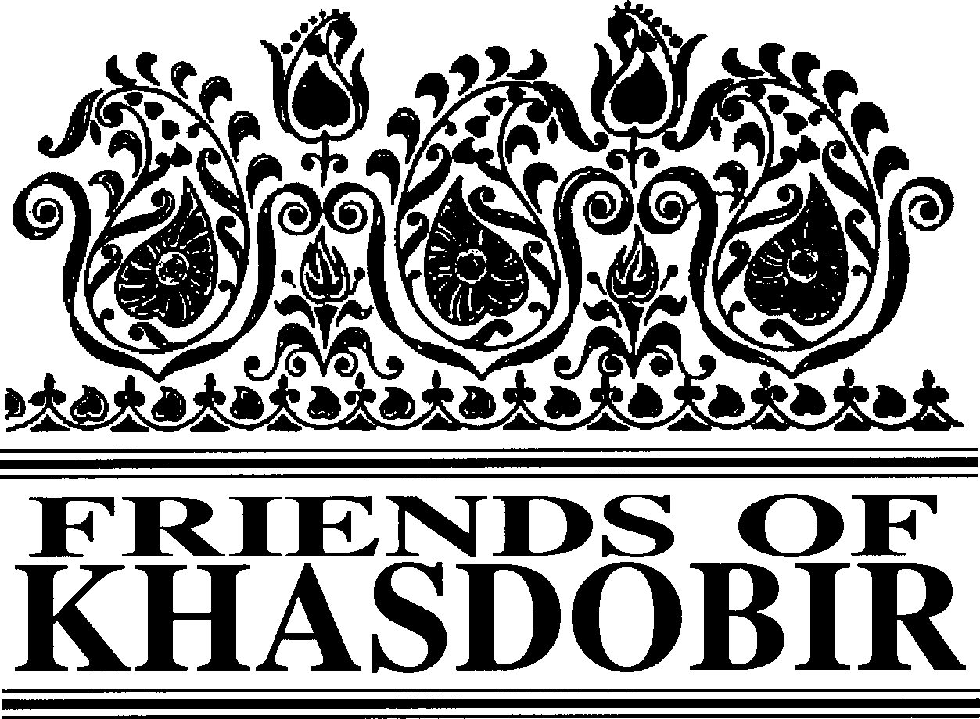
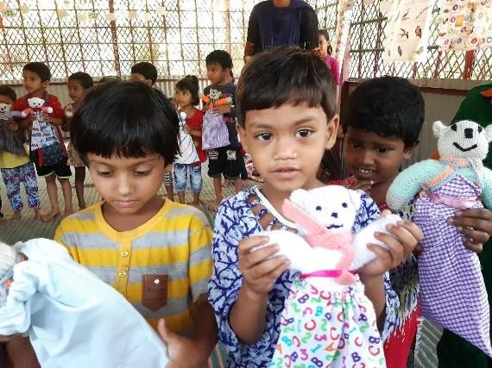
FIVE
FRIENDS OF KHASDOBIR, BANGLADESH, Registered Charity No: 1116316
Autumn 2019
A teddy for every child at our pre-schools
London Walk raises £224 for Friends of Khasdobir Adrian Dudman
Golden Giving
Successful sewing trainees presented with certificates Eating for Khasdobir
Coming up next…

in this issue >>>

A teddy for every child at our pre-schools
When Maureen, one of the trustees of Friends of It was not practical to take all the teddies at one time Khasdobir, visited the project last year one of the but enough teddies for 3-4 schools could easily be children told her that they would really like a fitted into one bag, so during several visits to teddy. A few weeks earlier Mike Sherriff, Bangladesh by trustees, teddies for all the children Chairperson of Friends of Khasdobir, had been are being delivered. Already teddies have been forwarded an email by Gill Elliot from Trinity distributed to children from 7 of our 10 schools.
United Reformed Church. The email was from The children have been very excited to receive the one of the organisers of a group in St Albans that teddies as they are from families where toys are knitted teddies to deliver to less fortunate children never purchased because of very limited household
all over the world. Thus, began the task of income (for example from work on the tea estates or
working out how to take 300 + teddies to driving a three-wheeler taxi). For the children a teddy Bangladesh! encourages use of imagination, manipulative skills
The Teddies are approximately nine inches in and learning of colours.
height and filled with acrylic fire- resistant stuffing. Many people of all ages and abilities knit the They are very soft and very light and squash Teddies. For some, knitting gives a purpose in times down easily to fit in luggage. Each Teddy comes of bereavement or illness. Also, it is a joy to teach with a drawstring bag and the children can also grandchildren to knit. There are groups, such as the get pleasure from the bag, using it store their few one in St Albans, throughout the country. For further
treasures or carry things to school. The Teddies details please see the web site:
themselves can be used as teaching aids in the http://teddiesfortragedies.org.uk classroom for children learning colours and
numbers.
Chairman Mike Sherriff
Treasurer Phil Watson, April Cottage, 12, Church Street, Rothley, Leicestershire, LE7 7PD Newsletter Editor Monjur Elahi, 47 Chart Downs, Dorking, Surrey, RH5 4DF Email: monjurelahi@msn.com Patrons: The Rt Hon Nicki Morgan MP; Sir Kevin Barron MP
Web Site www.khasdobir.org.uk

sLeo^{t} ^{t}n^{h}d^{e}o^{st}n^{ag}W^{e} >a>l>k raises £224 for Friends of Khasdobir
The London walk was established by people involved in Toc H who support the Khasdobir Project. Every year a walk visiting several faEmnimouasdLmoinnidmoennilaamn,dqmuisarks, is organised.
Walekreartsncoastnr uaelxseorctiatakteiopnart in a quiz. This year thuellawmaclokrpweransoastfruiveex-emrciile wander through BaytsawtioanteurllaamndcoNrpoetrteint g Hill, including part of KensiuinstgotoodnioGdiagrndiessnims.qTuhi e theme was Palaces,
blandit prPaoespenAtrltupatnad. Peter Pan.

This year the walk was dedicated to Barbara Ferryman (1962-2019) who was an enthusiastic walker and generous supporter of Friends of Khasdobir for many years.
If you are interested in taking part in the walk next year please email us at; khasdobir@btinternet.com
Adrian spent most of his working life on the staff of Toc H. Initially his role was to support and encourage Toc H branches in the North East of England before being appointed General Secretary and moving to Wendover. For the next several years he and I worked very closely together. Inevitably there were good days and not-so-good days but we remained supportive friends through it all and I look back on those years as some of the most fulfilling of my life. He was a colleague and close friend of Peter East and was excited to hear of the project that Peter helped to initiate and he and his wife Anne served for several years as Trustees of Friends of Khasdobir. Adrian had a remarkable ability to create an atmosphere of hilarity around himself and many will remember his flamboyant flogging at several AGMs of the lovely jam
nist^{s}h^{im}at^{qu}A^{i} ^{b}n^{la}n^{n}e^{di}m^{t} ^{p}a^{ra}d^{e}e^{sen}to^{t} ^{lu}r^{p}a^{t}iªs.e^{Tu}f^{m}u^{m}nd^{er}s for the charity. Everything he did was
deu^{le}n^{ni}d^{t} e^{au}r-^{g}p^{ue}in^{d}n^{ui}e^{s}d^{do}b^{lo}y^{re} h^{te}is^{feu}p^{g}rªo^{it}f^{n}o^{u}u^{ll}nª d religious faith but his Christianity was
factiolistia. Cl oinnecrlauttsiisvseectaentudercaodimp ipsclientgeellyit, non-judgemental.
sedheimrat wdiailml nmonisusmhmiymnibtehrmriabglnya ebruatt we will also feel a profound thankfulness
Everyone who knew
aliquam erat volutpat. Nam liber tempor
cum soluta nobis sed diam nonummy.
that he shared some part of life’s journey with us.
Ken Prideaux-Brune

On -line giving is an easy way to donate to Friends of Khasdobir. You can use your debit or credit card. If you are an income taxpayer, you can also complete a simple form so that Gift Aid is added to the donation.
Following the closure of BT My Donate Friends of Khasdobir decided to start using the Golden Giving platform. They are a not-for-profit charity giving platform that supports people to make a positive impact in society.
The platform can be used for birthday or Christmas donations or if you are organising a sponsored or other event to raise funds to support our work. Simply include the link and a message asking for support in your letters, cards or publicity. To date we have already received over £380 in donations through Golden Giving.
https://www.goldengiving.com/wall/friends-of-khasdobir

Stay with us, Support us!
We are compliant to EU General Data Protection Regulations

Do you receive the newsletter by post now and would you be happy to receive it by email?
Also notify us if you no longer wish to receive the newsletter (by either post or email).

Please email to khasdobir@btinternet.com

Eating for Khasdobir

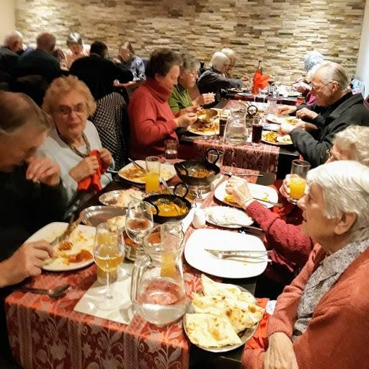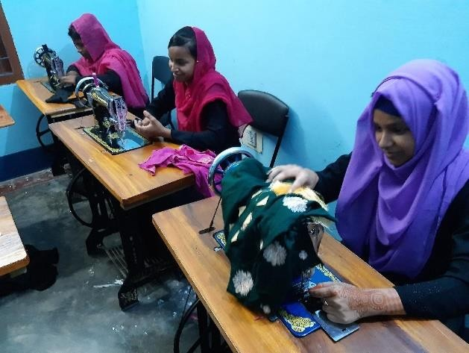30 sewing trainees from our sewing project received certificates at a celebration organised at the auditorium of the Government High School on 27th June 2019.
During the year 40 students enrolled on the sewing course. 10 students are continuing for a second year as they have not yet successfully completed the course.10 of the trainees are already earning a basic income using the skills they learnt during the course.
The Mayor of Sylhet, Ariful Haque Chowdhury, was the Chief Guest at the celebration, which was also attended by the President of Sylhet Press Club and the Assistant Director of the Department of the Bangladesh Prime Minister’s Office responsible for the work of Non- Government Organisations such as our project.

Three of the sewing trainees were presented with sewing machines at the function. One of these machines was purchased using income from the sale of clothes made by trainees during the course. The machines were presented to trainees who had good attendance, whose performance on the course was good and whose financial circumstances meant that they would benefit most from receiving a sewing machine. All the other trainees received sewing materials that they can use to make clothes for sale or for their families.

Have you ever considered raising money for the Khasdobir Project by eating? Sounds good? Then read on. People in Loughborough and Leicester have been doing just that three times a year for 24 years and raising thousands of pounds whilst enjoying a good meal with friends.
A small group of volunteers plan and organise the meals which usually attract 60- 70 diners over two sittings. Some people prefer to eat early in the evening, others are happy to eat after 8.00pm. There is no hard sell - no raffle, no speeches just an enjoyable meal with friends. For those who are alone we ensure that they are seated at a table with others, this way new friendships have
been formed over the years. We find that many very elderly people really look forward to these events and there is always a warm and welcoming atmosphere as well as lots of laughter. Our initial contacts were with friends, local churches, work colleagues, and indeed anyone who said they liked Indian food! The three course meal includes several choices of starter
and main course followed by coffee or ice cream. Prices are kept as low as possible to encourage attendance and we are extremely grateful to all the local Bangladeshi restaurants who willingly participate knowing that the project is in the area of Sylhet which is familiar to them. Indeed if a restaurant has not been used for a while staff are likely to ask when the next meal will be held at their restaurant. The meals are very popular and there seems to be no way of them stopping.
Advertising now is largely by email to individuals already on our mailing list, and other local sources.
If you would like more details of how the meals are organised please contact:
Kathleen Jackson at: derkat.46@ntlworld.com

coming up next >>>

At the end of the current financial year (31st March) we are changing our legal status to become a charitable incorporated organisation (more details in the next issue)

Please make a note of the date of our next Annual Meeting. It will be held on Saturday 4th July 2020 at 11.30am in Loughborough. As usual a curry will be served for lunch and there will be a full report about the work of the project.

YES, I’d like to help...
Charity Gift Aid Declaration – multiple donation
final

Boost your donation by 25p of Gift Aid for every £1 you donate
Gift Aid is reclaimed by the charity from the tax you pay for the current tax year. Your address is needed to identify you as a current UK taxpayer.
In order to Gift Aid your donation you must tick the box below:
I want to Gift Aid my donation of £ and any donations I make in the future or have made in the past 4 years to:

Name of Charity
I am a UK taxpayer and understand that if I pay less Income Tax and/or Capital Gains Tax than the amount of Gift Aid claimed on all my donations in that tax year it is my responsibility to pay any difference.
My Details

Title First name or initial(s)

Surname

Full Home address

Postcode Date

Please notify the charity if you:
- want to cancel this declaration
- change your name or home address
- no longer pay sufficient tax on your income and/or capital gains

If you pay Income Tax at the higher or additional rate and want to receive the additional tax relief due to you, you must include all your Gift Aid donations on your Self-Assessment tax return or ask HM Revenue and Customs to adjust your tax code.

Please send this page to:

Phil Watson, April Cottage, 12, Church Street, Rothley, Leicestershire, LE7 7PD

