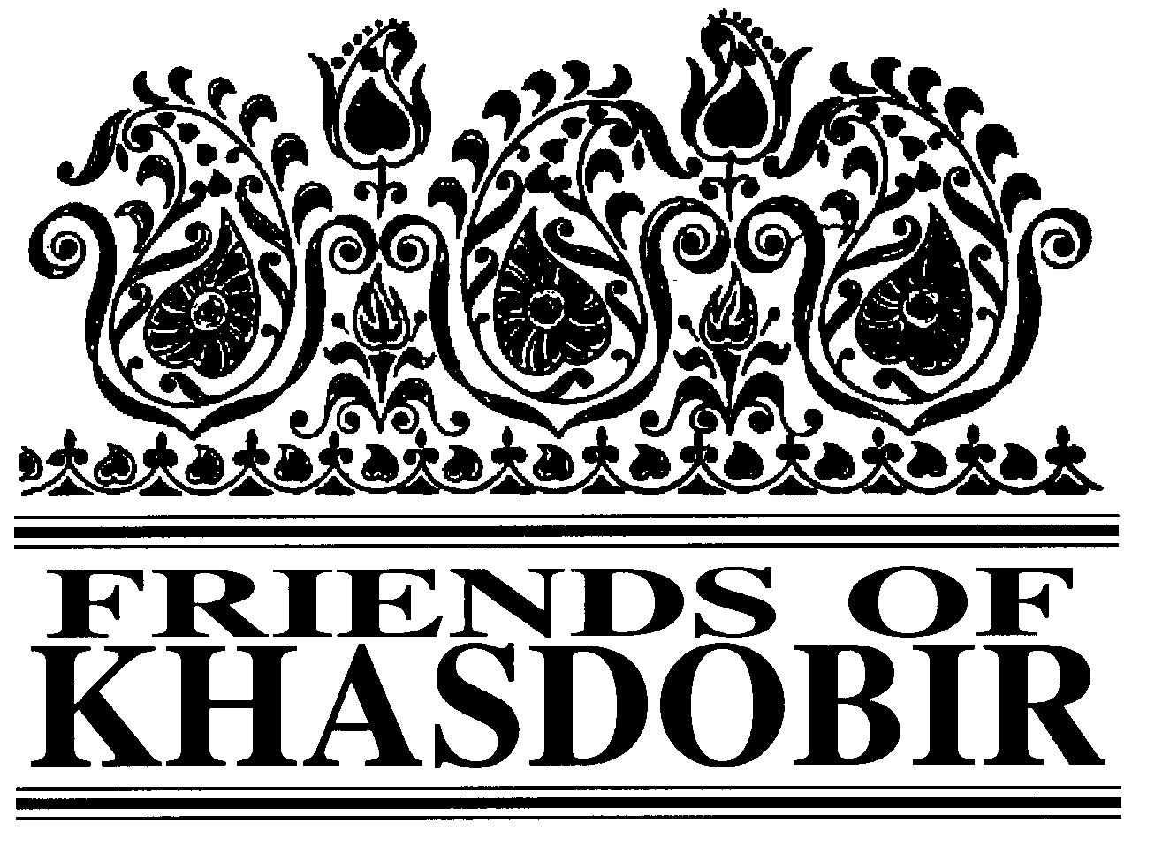
FRIENDS OF KHASDOBIR, BANGLADESH
Registered Charity No: 1116316

NEWSLETTER
SPRING 2018

ALL CHANGE IN SYLHET
This year the trustee visit was made by Phil Watson along with Mike Sherriff, our Chair, who was already in Sylhet and had spent several months with the project. Our need at present is to modernise the project so that it can take on the new challenges presented by significant demographic changes in the area and the growth of alternative pre-school provision. Phil reports

As always there were visits to all the schools, observing the teaching and learning and enjoying the delightful atmosphere created by the children. One of our most important recent developments has been targeting the creation of sheltered buildings so that children can attend all year round - attendance at SUSs when it rains is inevitably low or non-existent. Thanks to the help of Muslim Charity and Sylhet Jubo Academy we now have an excellent building on the site of the Lakkatura 1 school, with toilet and water provision plus electricity. During the visits a second facility was confirmed at the Gowaipara site. In addition the Sumon Momen school is now

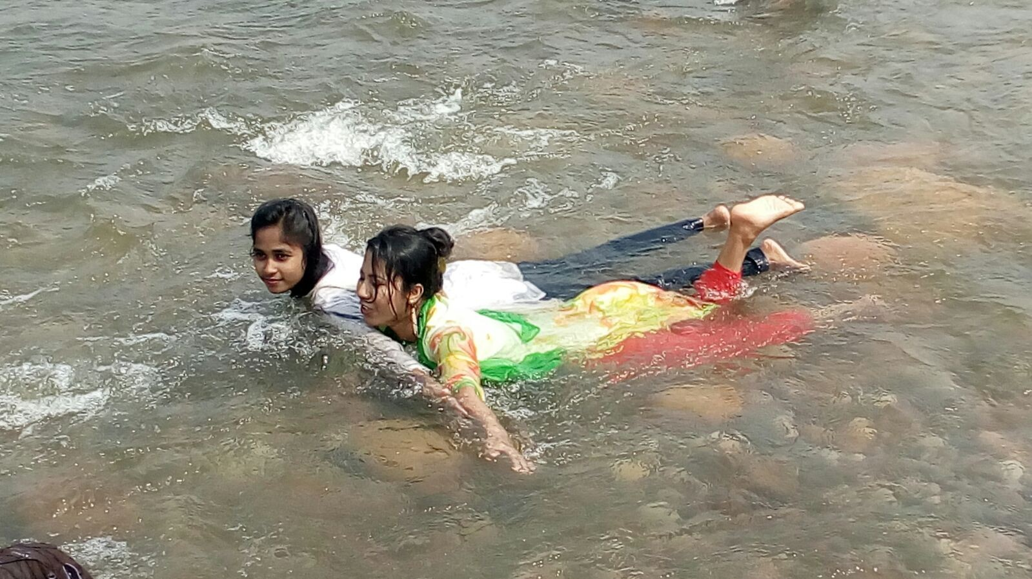
Enjoying the water during the picnic
meeting indoors in the rooms we rent for our office.

Unfortunately, the numbers of children in our schools has fallen steadily in recent years and it is now difficult to justify the current teacher/child ratio. Much of the time, therefore, was spent finding the best way forward for

managing this challenge. This involved holding meetings with similar organisations in the area and looking for ways in which we might collaborate to ensure we maintain, in the long term, both the spirit established 34 years ago by Harun and Peter, and a
Continued on page 2

Chairman Mike Sherriff
Treasurer Geoffrey Pool, 7 St John’s Road, Stoneygate, Leicester, LE2 2BL
Newsletter Editor Ken Prideaux-Brune, 13 Hollybush Lane, Amersham, Bucks. HP6 6EB. Tel: 01494 433871. Email: pbrune@olcs.net.
President KYAG Kabir Ahmed, KYAG, PO Box 118, 3100 Sylhet, Bangladesh Patrons: The Rt Hon Nicky Morgan MP; Sir Kevin Barron MP Web Site www.khasdobir.org.uk

Methodist Appeal Success
We reported in the autumn issue that the Thirsk and Northallerton District of the Methodist Church has adopted Friends of Khasdobir as its charity of the year.

By the first week of April this year the various fundraising efforts of the churches in the District had raised
£6,639.49. And there are still three months of the appeal to run.

Our profound thanks to everyone involved whose hard work and generosity have achieved this remarkable result.

Our AGM
Saturday June 30. 11.30 am Rosebury St Peter’s Community Centre
Storer Road Loughborough, LE11 5EQ
Your chance to learn more about the changes outlined in this newsletter and to support the Trustees. For catering purposes please let Kathleen Jackson (derkat46@ntlworld.com. or 01509 557740) know you’re coming.

Colleges, Christmas Puddings and a Corpse
That’s the theme of this year’s London Walk on

Saturday September 1.
However well you know London you’re likely to learn something new on this stroll round Fitzrovia.

Details and registration forms available nearer the time from Jeni Gosling, 29 Westell Close. Baldock, SG7 6RY. J.gosling@btintenrnet.com.

All Change - Continued
flowing waters and visit the markets on the Indian side. The journey was long but

progressive future for those
we serve in Khasdobir. We have identified the Sylhet Jubo Academy as an organisation with similar values to ours and one which has the capacity to support both the financial and personnel elements of our work.

Following the visit, we are now looking to explore this opportunity further with a view to implementing a close working relationship from July this year. We shall be targeting more sites to build covered schools and the possibility of renting sites if we cannot build. The aim is to provide higher quality provision for our children across a reduced number of schools to make more effective use of the funds so generously donated to our cause.
These buildings will also
enable the project to reach out into the local community providing learning opportunities for young and old. Already Lakkaturah 1. is being used regularly for computer classes provided by CAFFE (Computers Are Free For Everyone), a “games for all” session has been planned and a musical entertainment evening. The possibilities are endless - the challenge will be in the organisation.

The visit also involved visits to the coaching classes, still going strong under the watchful eye of President Kabir and of course, the Picnic, which Trustees fund personally for these students. The trip was to Bishnakhandi on the Indian border, where students could wallow in the fast
everyone had a great time.

The sewing class continues to attract students but here again we are utilising the offer of some research into increasing the effectiveness of this provision. We await with interest the results of the research, conducted by students at the Shajahal University. On the welfare side, we continue to provide monthly payments to 70 widows.

So a busy and productive visit - but there is much still to be done and the Trustees are extremely grateful for the excellent work by Mike in spending so much time looking into the detailed day- to-day working of the project. The changes we are now hoping to implement would not have been possible without his invaluable insight.

Planned Management Changes
Mike Sherriff, Chair of Friends of Khasdobir, outlines the changes in the management of the Khasdobir project that will take place from July 1

As supporters will know the Khasdobir Project was set up in the 1980s with a committee of local people from the Khasdobir area and support from the UK. Many of the people involved have been working with the project since it started. However, since those early days the regulations and requirements for charities in the UK sending funds abroad have increased. In Bangladesh too, the requirements of the Government before authorising project funds from abroad are now greater.

The current agreements between Friends of Khasdobir, Khasdobir Youth Action Group and the Government of Bangladesh come to an end on June 30. After very careful consideration and discussions with Khasdobir Youth Action Group the Trustees in the UK have concluded that stronger organisational arrangements are necessary to ensure that the funds allocated, and the staff employed by the project, are managed effectively. During Phil’s visit there were detailed discussions with several larger NGOs in Sylhet about the possibility of them managing the work of Khasdobir from July 1.

The conclusion of the discussions is that we will be establishing an agreement, initially for one year, with the

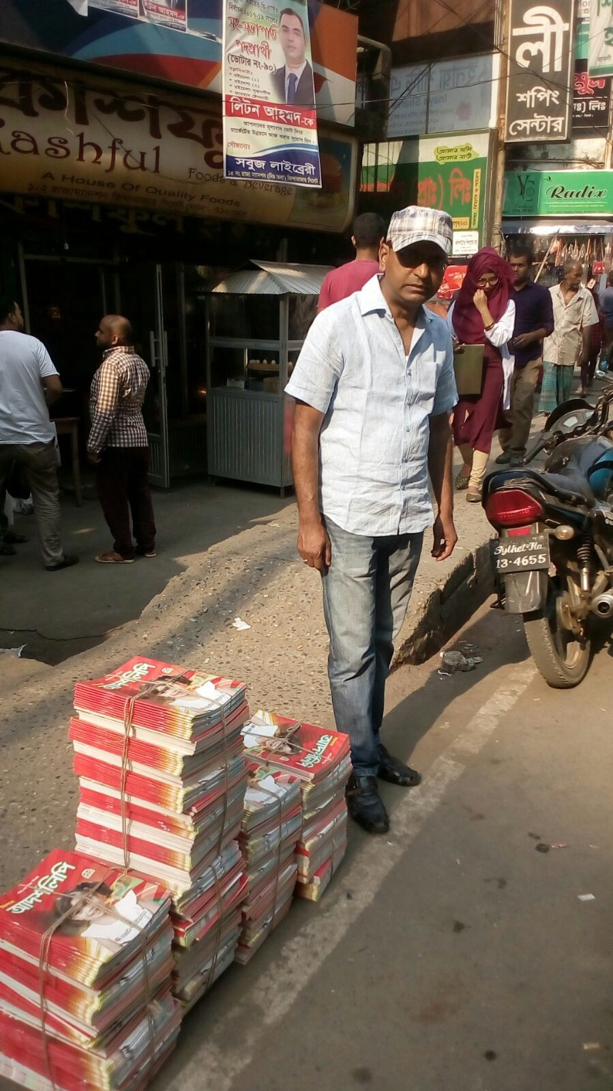
Afzol, Schools under the Sky co- ordinator, with 500 books bought for the schools.

Sylhet Jubo Academy to run the Khasdobir Project. We have already worked successfully with them to construct our first sheltered school, funded by Muslim Charity. This project was too large for Khasdobir Youth Acton Group to manage directly, hence the decision by Muslim Charity and KYAG to ask Sylhet Jubo Academy to take on this project.

The project over the next year will be very similar to our current work and most of the current staff will be employed by Sylhet Jubo Academy from July 1. The project will include 10 pre- schools - three with a shelter and seven open air - the coaching class, the sewing
workshop and monthly allowances paid to 70 needy widows. During the year we hope to find more shelters, develop the sewing workshop and develop long- term plans for the future. A Project Manager has been recruited to manage the work and the project will operate in accordance with the financial and staff procedures of Sylhet Jubo Academy. There will be a committee of local people who will advise on future developments and this will include many of those living in the area who are currently supporting the project.

Sylhet Jubo Academy (SJA) was established in August 1991 by a small group of philanthropists, led by former United Nations Volunteer, A H M Faisal Ahmed. Their aim was to develop a locally based, not- for-profit and non-political development organisation that would operate at a “grassroots” level to address the needs of economically and socially marginalized members of the community in Sylhet. Full participation from the community is a core feature of SJA’s projects and it is flexible in responding to the needs of people. Since its formation SJA has managed projects funded by many different agencies and in Bangladesh as a whole has pioneered work on HIV/AIDS prevention, Early Childhood Support and ending violence against women and children.

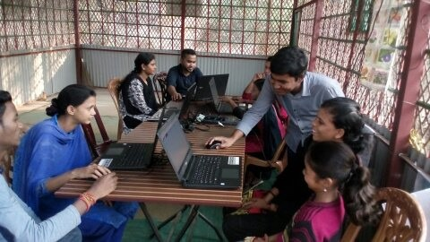
Free Computer Classes

Mike Sherriff

As mobile phones come down in price and more jobs require people to be able to use a computer, learning about computers has become something of great interest to the KYAG coaching class students. We are therefore pleased to be working with the UK charity Computers Are Free For Everyone (CAFFE) that was set up by a former Voluntary Service Overseas (VSO) volunteer who used to work in Sylhet. With CAFFE we are now providing free

CAFFE computer class at Peter’s School

computer training at Peter’s school on the tea estate and at our coaching class centre. There are two sessions for the students each week.

For the classes we use basic lap top computers and can connect to the internet using a mobile device. Our students have already been

introduced to computer basics and will now move on to learn how to design simple web sites. Eventually this should lead to opportunities to earn small sums of money, which will help the students to finance their future education and provide a route out of poverty.

We hope you look forward to receiving this newsletter with news of the project which we support in Bangladesh but should you no longer wish to receive it for any reason please write or email:

MONJUR ELAHI, 47 CHART DOWNS, DORKING RH5 4DF
Email: khasdobir@btinternet.com.

Who maintains our database. This is solely to enable us to send you this newsletter and our Annual Report and Accounts. Your details will never be shared with any other organisation.

If you are currently receiving the newsletter by post but would be happy to receive it by email please email the address above.

I’d like to help...

Title Forename(s) _Surname: _ Address
Post code

I enclose my contribution of £ Please make cheque payable to Friends of
Khasdobir. And send to:

Geoffrey Pool, 7 St John’s Road, Stoneygate, Leicester LE2 2BL

