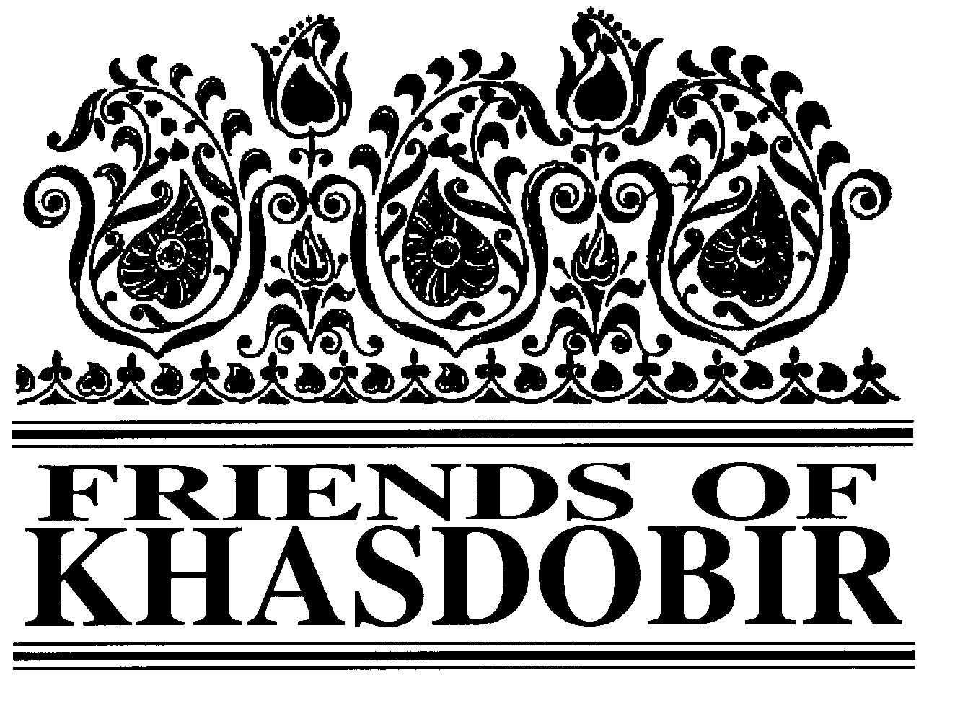

Volunteers for Bangladesh Work with KYAG
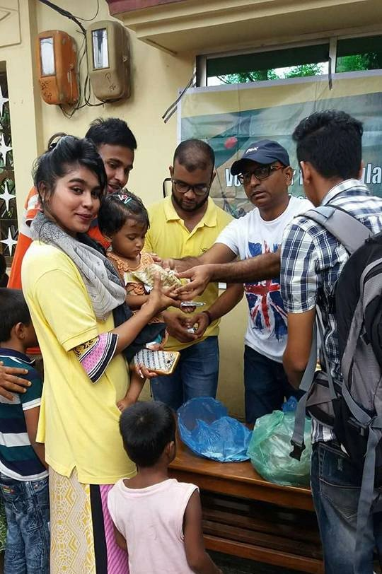

shoes and snacks at a function organised by the volunteers and attended by committee members from KYAG and representatives of the local community.
Volunteers for Bangladesh is
a national initiative by young people in Bangladesh. It was established in 2011 to provide the youth of Bangladesh with a voice and platform to contribute to nation building. It enables young people to take the initiative and transform their ideas into action.

In Sylhet a former coaching class student is a leading member of Volunteers for Bangladesh and she has been encouraging other coaching class students to get involved too.

The young volunteers from all over Sylhet have undertaken
2 projects with KYAG and plan to do more. The first project was shoe distribution to children from one of our Schools Under the Sky on the tea
volunteers
sponsors
estate. The
found local
who provided
shoes.
Along
with
the
teachers from the school the
feet of all the children were measured so that the shoes provided were of the relevant size. A few days later every child was provided with

The second project was at one of the Schools Under the Sky in the town. This project
raised awareness amongst the children about health and hygiene. The children were provided with fruit and tips on healthy living.

The volunteers hope that their next project will be with the widows supported by KYAG.

Chairman Mike Sherriff
FRIENDS OF KHASDOBIR, BANGLADESH
Registered Charity No: 1116316
NEWSLETTER
AUTUMN 2017

Treasurer Geoffrey Pool, 7 Stoneygate, Leicester LE2 2BL
Newsletter Editor Ken Prideaux-Brune, 13 Hollybush Lane, Amersham,
Bucks. HP6 6EB. Tel: 01494 433871. Email: pbrune@olcs.net President KYAG Kabir Ahmed, KYAG, PO Box 118, 3100 Sylhet, Bangladesh Patrons: The Rt Hon Nicki Morgan MP; Sir Kevin Barron MP
Web Site www.khasdobir.org.uk
Supporting

Gourmet Soups for Sylhet
Beverley Lott reports on the soup lunches in aid of Friends of Khasdobir run for many years by the Soar Valley Twinning Association

In the early 1980s, Soar Valley Twinning Association decided that we should like to support a community in a less economically developed country. Our French partners had led the way in Tikaré in Burkina Faso and some of our members have been on twinning visits with them to meet our Burkinabè counterparts and experience life in their Sahel villages.

We were put in touch with Kathleen Jackson who, with her knowledge of the Bangladeshi community in Loughborough, introduced SVTA members to people from Sylhet. The Kegworth monthly soup & dessert lunch was launched, initially offering a seasonal soup and fruit pudding at Kegworth

Rajab Ali Khan
We were sad to learn of the death of Rajab Ali Khan of Green Disabled Foundation. “All those who visited Sylhet in recent years,” says Mike Sherriff, Chair of Friends of Khasdobir “will have met him and know of the fantastic work he did to promote disabled people's rights.” Phil Watson, who made the most recent official visit to KYAG, adds: “What an amazing character and what extraordinary work he has done for the foundation. He was lovely to be with, amusing, so strong willed, charismatic and much loved. He will be greatly missed. We shall never forget the times we spent with him, and nor will others.” He will be much missed by everyone connected with KYAG.
Community Centre under the leadership of Judith Clegg. The lunch, now a gourmet experience with 3 choices for each course, has continued, led by SVTA secretary Sheila Hawksworth, with a regular clientele, augmented by anyone who cares to drop in from 12 noon on the second Wednesday of each month. The venue has moved to Kegworth Village Hall.

On one occasion a large group of young people from rural China, on a visit to the nearby Nottingham University School of Agriculture, was warmly welcomed. The soups and desserts are prepared by a volunteer team

London Walk raised nearly
£1,700
This year’s fundraising walk at the beginning of September explored Chelsea and had raised just under £1,700 at the time of going to press. Just over £1.200 was raised by two former Trustees – John Burgess and Anne French; Anne walked and John signed up the sponsors.
and all the proceeds after deduction of expenses are sent periodically by our treasurer to the Friends of Khasdobir account. In the last
5 years the annual donation has averaged £635.

These monthly lunches require a dedication of time and talents and regular commitment on the part of the volunteers. News of Friends of Khasdobir is reported at SVTA committee meetings, some of our members attend the AGM and fund-raising restaurant meals in the Loughborough area, and we are keen to maintain our support of the project.

Methodist Circuit Supports Us
Through the good offices of long-time Toc H member Mary Edwards the Northallerton Methodist Circuit has adopted Friends of Khasdobir as its charity of the year. Trustee Kathleen Jackson spoke about our work at the service which launched the year and the churches in the Circuit will be running fundraising events during the year.
St Albans Fundraising Meal New Gulshan Restaurant
141 Victoria St. St Albans AL1 3TT
Just a 5 minute walk from St Albans Station
Sunday October 22 from 12.45 pm
Meat or vegetable somosa followed by chicken or vegetable curry
£20 (of which £10 comes to Friends of Khasdobir) To book contact Mike Sherriff, 44 Simmonds Way,
St Albans AL4 9AP or email mike.sherriff@talk21.com

Deep in the Endless Forest
Extracts from the winning essay by Ima Akhter following the coaching class picnic this spring.

We have been living a monotonous life in town for a long time. It was therefore good news that we would be going on a study tour with our coaching class. We went to Srimongol for our picnic. There were 3 honourable guests with us from England during the picnic.

On the day of the picnic the bus stared at 9 am. There was a sound system within the bus. We enjoyed much singing songs, reciting poems and dancing in the running bus. Of all, our main attraction was Dr Derrick Jackson, Mrs Kathleen Jackson and Mr Mike Sherriff. Of them Mr Mike understands and can speak Bangla and he even sings

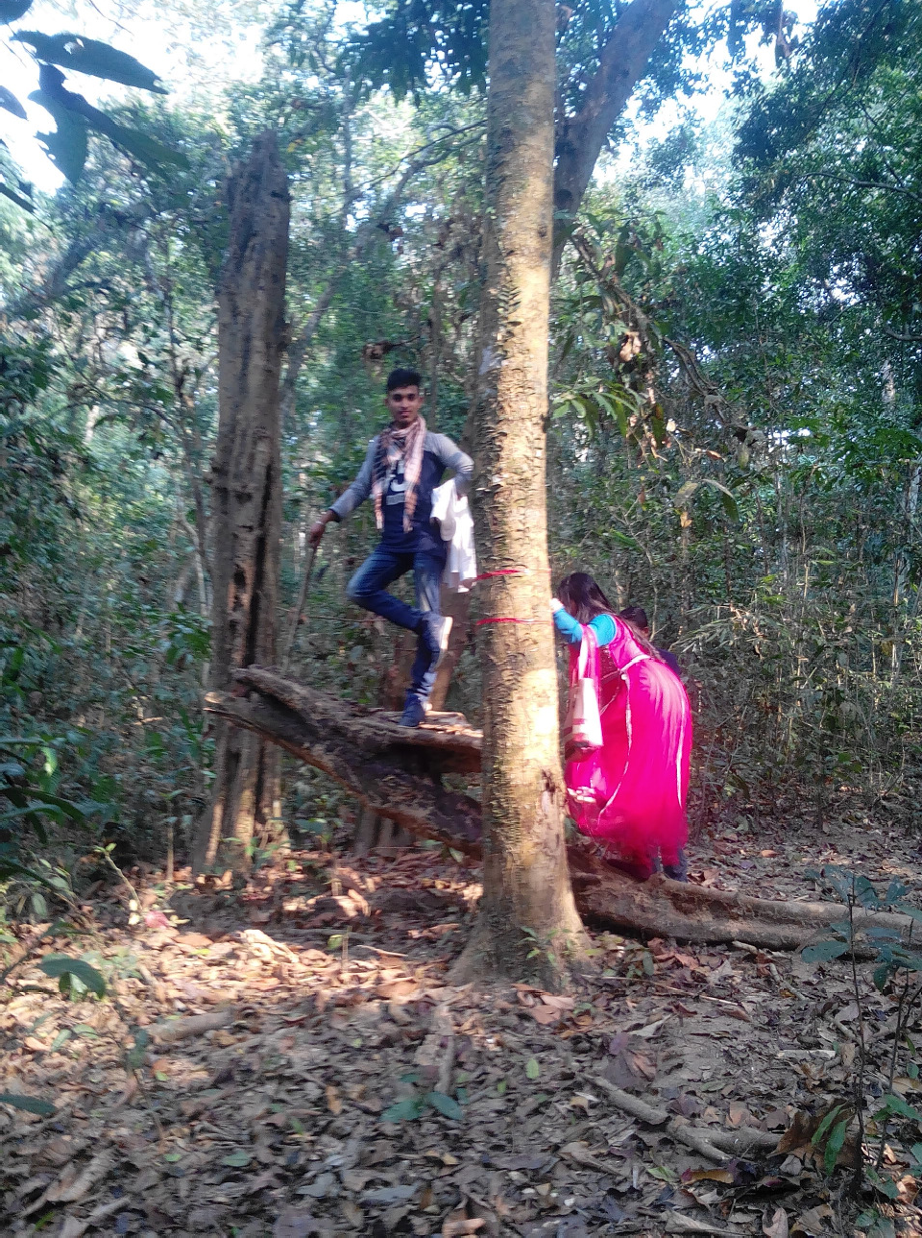

Park. At the Eco Park we took our lunch sitting at the ticket counter for the forest. It is a deep forest where various
types of ferocious beast like tiger, boar, poisonous snakes and various kinds of bird live. Mr Mike purchased tickets for us and hence we all entered into the park.

We entered into the deep endless forest. Suddenly President Kabir, Sir, with some others was lost in the forest. We could not see them. We had our guide with us. We also lost him and we could not find our way to the exit. We got afraid but luckily our guide appeared and led us to the place. Then we found President Kabir, Sir on that spot. We were very pleased to get back to our friends and teacher.

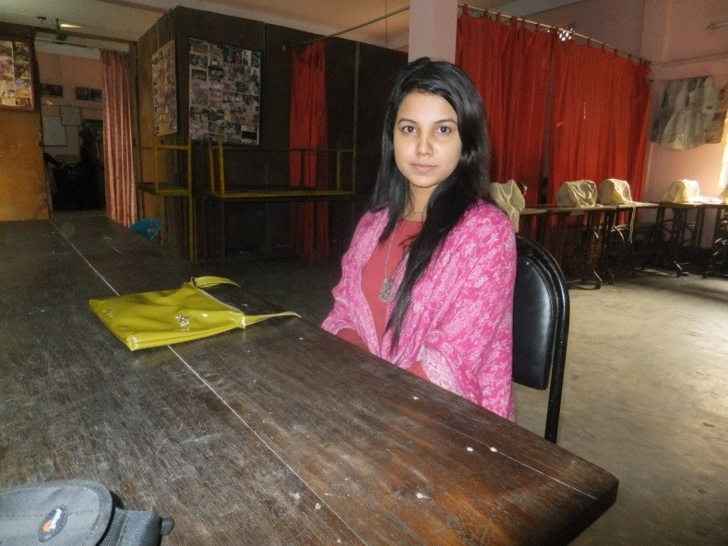
Bangla songs. He presented a folk song, Lalon Giti, with his sweet and lovely voice. We got delighted at the presentation of his Bangla song.
Yasmin

The bus was proceeding. Green trees and plants on both sides of the highway drew our attention with a sense of sweet love. We lost ourselves at the attractive and charming beauty of nature. We are deep in thought as we reached Nilkonttho a seven colour tea stall at Srimongol. There we witnessed the rehabilitation of the tribal areas of the Monipuri life. We saw the tea and rubber plant gardens and took rest under the shadow of trees.

Later we went to the spot where a good number of people were shot dead by the Pakistani invaders during the war of Liberation, 1971, and then to the National Eco

Yasmin is a teacher in the coaching class, teaching finance and accounting. She teaches in the class five mornings a week from 7 am to 8 am. She is currently a student at the Metropolitan University, one of the new private universities in Sylhet. She will graduate in December 2017 with a Bachelor of Business Administration with a focus on accounting. Yasmin was

also a student in the coaching classes, starting when she was in year 6 of secondary school. She told us she found the classes very useful, as they helped hugely with her school work. She has two older sisters and one older brother all of whom also attended coaching classes. One of her sisters (Rukshana) used to be an adult literacy teacher with KYAG and is now a teacher in Chowkidiki School Under the Sky.

YES, I’d like to help...

Title Forename(s) Surname:

Address

Post code

Please complete either Section A or B and if you are a UK taxpayer and have not already done so please sign the Gift Aid form in Section C, making each pound you contribute worth an additional 25p. Then send this page to:
Geoffrey Pool, 7 St John’s Road, Stoneygate, Leicester LE2 2BL

A - by Cheque (payable to Friends of Khasdobir). I enclose my contribution of £...............

B – by Banker’s Order
To: ……………………………………………….
(Name of Bank)
……………………………………………………

……………………………………………………

……………………………………………………
(Address of bank)

Please pay to:
Friends of Khasdobir. At Barclays Bank, Town Hall Square, Leicester, Branch. Sort Code: 20 49 17. Account no: 20587192

The sum of £………… on …… ……………20……..
And thereafter the same amount on the same day each month until further notice.

………………………..………………(Signature)

…….…………….(date)

.............. .…………………………….(Account No.)

C – Gift Aid
I am a UK taxpayer and would like Friends of Khasdobir to reclaim the tax I have paid on any donations I make to them.

Signed ………………………………….

Date ……………………………

Notes:

This declaration is in force from the above date until it is cancelled. It need only be made once.

You must pay in tax (income tax and capital gains tax added together), at least the total of all donations that you make to charities each year. The donation that you make to the Friends of Khasdobir, Bangladesh is included in this total.

If your financial circumstances change, and you cease to pay income tax or capital gains tax at a level at least equal to the sum that you donate to all charities each year, then please let Friends of Khasdobir know by writing to the Treasurer.

