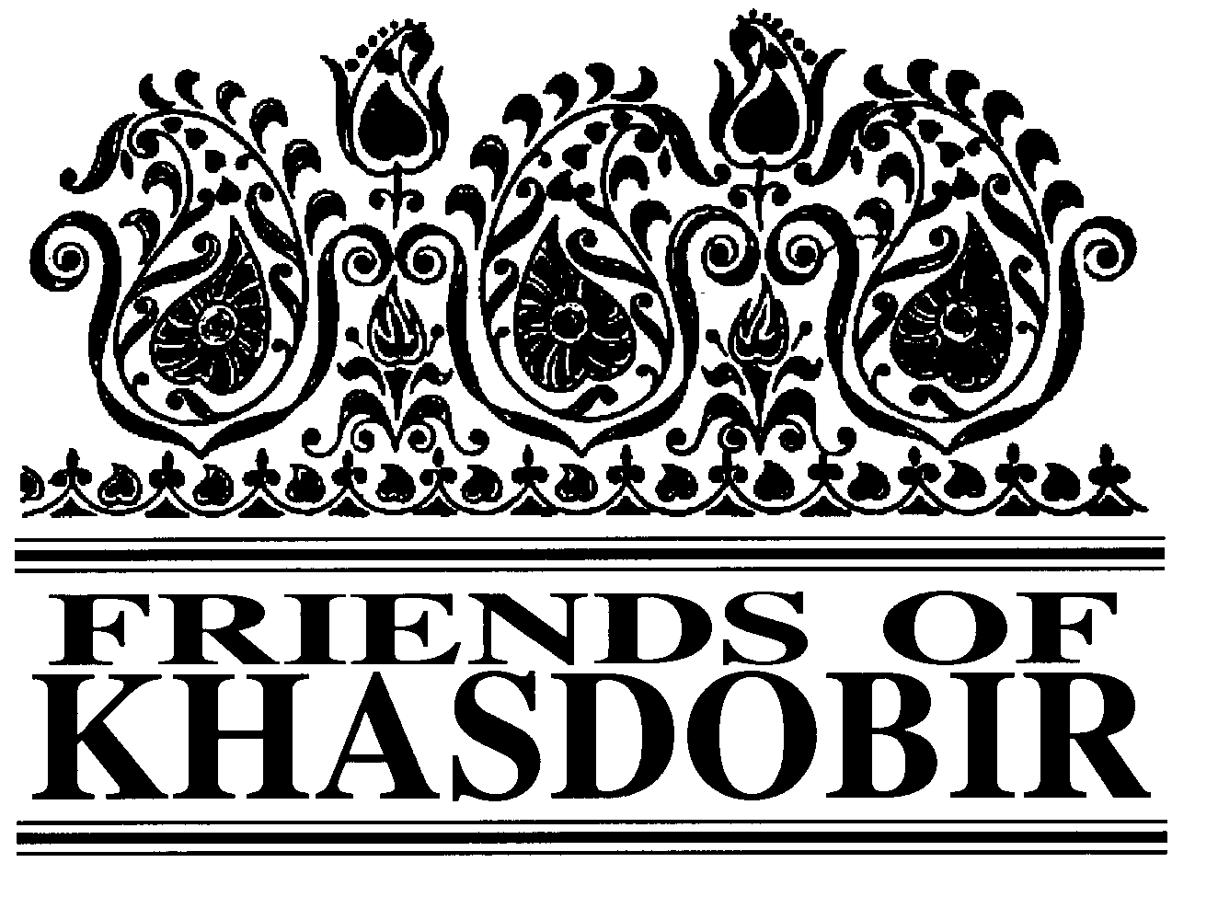
Friends of Khasdobir, Bangladesh
Charity Number 1116316

11th Annual Report and Accounts
To 31st March 2017
Patrons: The Rt Hon Nicky Morgan MP, Sir Kevin Barron MP
Trustees

Mr Mike Sherriff (Chair) Mrs Moyra Blake
Mrs Jean Brown
Ms Maureen Haddock Mrs Kathleen Jackson Mr Kazi Mashud
Bankers: Barclays Business Banking.
Ind. Examiner: ICFS Agar FCA
Web site: www.khasdobir.org.uk.

History and Objectives
Friends of Khasdobir came into existence at our inaugural meeting on July 8th 2006 and our registration as a charity was completed in October 2006. For several years prior to that we operated as part of Toc H under the name Toc H Friends of Khasdobir. The objects of Friends of Khasdobir, Bangladesh are:

To advance the education of children, young people and adults in Bangladesh, in particular by supporting the work of the Khasdobir Youth Action Group to provide and assist in the provision of facilities for education in the area currently known as Sylhet.

The relief of financial hardship among people living in Bangladesh, in particular by supporting the work of the Khasdobir Youth Action Group to make grants of money and provide goods, services or facilities for the relief of the poor living in the area currently known as Sylhet.

To advance the education of the public in England and Wales in the subject of development in Bangladesh.

Structure, Governance and Management
The Charity is governed by a Constitution adopted at a General Meeting held on July 8th 2006. Trustees, most of whom have visited the

Mr Monjur Elahi (Mithu)
Mr Geoffrey Pool (Treasurer) Ms Sue Simmons
Mrs Doreen Watson
Mr Philip Watson (Secretary)

These accounts will be presented at our AGM on
Saturday July 1st
11.30 am
Rosebery St Peter’s Community Centre, Storer Road , Loughborough LE11 5EQ

We do hope many of our supporters will come to what is usually an enjoyable and enlightening occasion – someone has even described it as the “highlight of the year”!
So we know numbers for the curry lunch please phone or email Kathleen Jackson (01509 557740 –
derkat.46@ntlworld.com.) by June 25 to let her know you are coming.
project we support in Bangladesh at one time or another, are elected annually at the Annual General Meeting.

Review of the year
The slide in the value of the pound this year has meant that the money we send to KYAG brings them fewer taka. As a result Trustees sent an additional £3,000 during the year (over and above the £48,000 pledged) and Chair of Trustees Mike Sherriff and fellow Trustee Phil Watson spent a considerable time with the KYAG committee looking at ways in which they could trim their expenditure without damaging the project. The area has changed considerably since the early days of the project. Young people now have mobile phones and use the internet and many more older women are

Continued on page 2

Continued from page 1

able to read and write. As a result it was agreed to close the adult literacy classes and reduce the amount spent on welfare. More work is now being done with parents of children attending the schools and parents’ meetings have been established.

Mike Sherriff had an extended stay in Sylhet during the year and while there he was able to assist the KYAG committee to organise their first significant local fundraising event in Sylhet. He was joined by fellow Trustees Kathleen Jackson and Kazi Mashud, who were both on private visits to Sylhet, at a well- attended fundraising meal, which raised £77. Trustees are encouraged by this indication that the KYAG committee recognises the importance of local fundraising.

The London-Paris cycle ride proved a wonderfully successful fundraiser for Friends of Khasdobir, thanks to the efforts of the ten intrepid cyclists both in riding and in gaining sponsorship. Although the Gift Aid repayment on donations received through MyDonate is included in this year’s accounts there is a further £1,600 due on donations paid direct to Friends of Khasdobir which will be included in next year’s claim. The total received from this venture was just over £16,500.

Although the exchange rate was unfavourable we benefited from the rise in the stock market during the year and so, despite a deficit on the year’s working of £1,800, we saw a substantial rise in the value of the charity’s assets, which Trustees treat as an endowment fund producing an income for them to spend each year. This year’s income from investments was a little over £7,000.

The donations received from groups were down to a little over £500, accelerating the trend of recent years but the total received from individuals showed a very encouraging increase. KYAG remains a very remarkable project, serving some of the poorest people in Bangladesh and we are deeply grateful to all our donors who make it possible for us to continue to support KYAG’s work.

Risk Assessment
The Trustees have considered the risks to which they may be exposed and have policies
Trustees Moyra Blake and Sue Simmons visit KYAG
We decided to make this an informal visit, paid for by ourselves, so that Sue, as a new trustee, could have a gentle introduction to Bangladesh and the work of KYAG. We spent seven days in Sylhet and saw coaching classes and the sewing class, talked to teachers and students, visited several Schools under the Sky, met members of the committee and explored ways of enabling KYAG to cope with a diminishing budget caused by the weakening exchange rate.

Every year on February 21, Bangladesh celebrates the day in 1952 when Bangladeshis fought to have their language, Bangla, recognised as the language of the country. Five people died during the struggle. KYAG wanted to celebrate this special day, so a group of staff, teachers and children carried a banner through the town to the Shahid Minar, the monument erected in many towns to commemorate the day and honour the martyrs. The children came without their parents and all behaved impeccably. Despite being very young they understood this was an important occasion. We were interviewed by several radio and TV stations keen to know what foreign visitors thought about the celebrations.
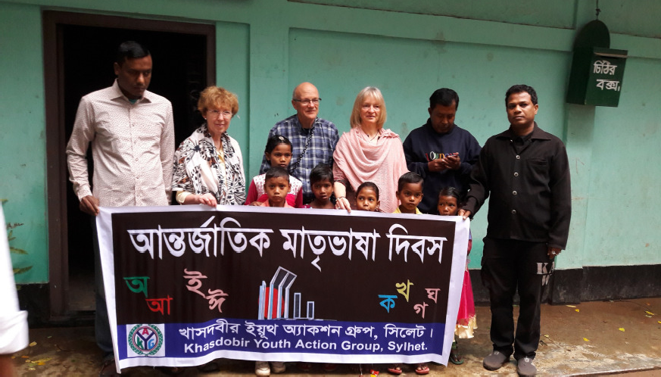
L to r Sue Simmons, Mike Sherriff and Moyra Blake with children holding KYAG’s banner

in place to manage these to an acceptable level.

Public Benefit
The Trustees confirm that due regard has been given to the Charity Commissioners’ guidance on public benefit issued in February 2014. The work of KYAG in Bangladesh, which they support, assists the very poorest people in that area without charge. Through the newsletter sent to donors and through the fundraising meals Friends of Khasdobir educates citizens of the UK about the problems faced by poor people in Bangladesh. The Trustees are confident that they provide public benefit.

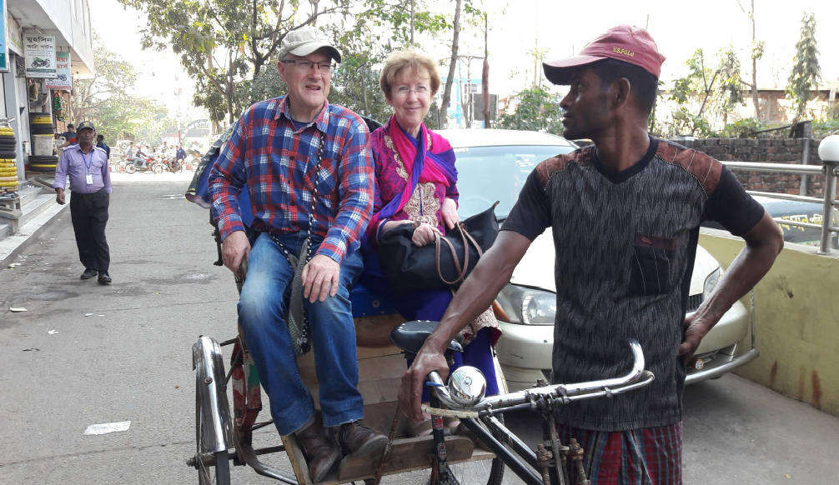

Sue Simmons embarks on her first-ever rickshaw ride accompanied by Chair of Trustees Mike Sherriff

For more news and pictures do please visit our website:
www.khasdobir.org.uk
Come and Explore Chelsea Saturday September 2 Check-in from 10.30 am
The area to be explored this year is Chelsea. It has a rich history and has been home to many poets, painters and pensioners as well as Winnie-The-Pooh, assorted royal mistresses and Sir Thomas More. The full course is 5 miles, and the short course about 3.5.

Entry is free for those sponsored for Friends of Khasdobir. Otherwise pay £7, receive the booklet about the route and walk for fun.

To register your interest in the Walk and receive further details nearer the time contact: Jeni Gosling, 29 Westell Close, Baldock, SG7 6RY.

Email: j.gosling@btinternet.com.

Independent Examiner’s Report to the Trustees on the unaudited financial statement of Friends of Khasdobir, Bangladesh (on Page 4)

I report on the accounts of Friends of Khasdobir, Bangladesh, to 31st March 2017.
Respective responsibilities of Trustees and Examiner

As the charity's trustees you are responsible for the preparation of the accounts, you consider that the audit requirement of section 144(2) of the Charities Act 2011 (the Act) does not apply and that an independent examination is needed. It is my responsibility to examine the accounts under section 145 of the Act, to follow the procedures laid down in the General Directions given by the Charity Commission under section 145(5)(b) of the Act, and to state whether particular matters have come to my attention.
Basis of Independent Examiner’s Statement

My examination was carried out in accordance with the general Directions given by the Charity Commission. An examination includes a review of the accounting records kept by the charity and a comparison of the accounts presented with those records. It also includes consideration of any unusual items or disclosures in the accounts, and seeking explanations from you as trustees concerning any such matters. The procedures undertaken do not provide all the evidence that would be required in an audit and consequently no opinion is given as to whether the accounts present a “true and fair view” and the report is limited to those matters set out in the statement below
In connection with my examination, no matter has come to my attention:
- which gives me reasonable cause to believe that in any material respect the requirements:
  - to keep proper accounting records in accordance with section 130 of the Act; and
  - to prepare accounts which accord with the accounting records and to comply with the accounting requirements of the Act
have not been met; or
- to which, in my opinion, attention should be drawn in order to enable a proper understanding of the accounts to be reached.

ICFS Agar FCA
Robert Whowell & Partners
CHARTERED ACCOUNTANTS AND STATUTORY AUDITORS
78 Loughborough Road, Quorn, Leicestershire, LE12 8DX

Friends of Khasdobir - Charity 1116316
RECEIPTS AND PAYMENTS ACCOUNT
for the year ended 31 March 2017
 |  |  |  | Restated
 | Year to | 31/03/2017 |  | Year to 31/03/2016
RECEIPTS
Donations from individuals |  | 19,878.27 |  | 17,458.06
Donations from groups |  | 526.00 |  | 2,280.00
Sponsored Bike Ride |  | 17,296.62 |  | 0.00
Fundraising meals |  | 4,195.51 |  | 2,902.20
London Sponsored Walk |  | 838.00 |  | 1,950.09
Sale of calendars, jewellery etc, |  | 30.00 |  | 0.00
Legacies |  | 2,000.00 |  | 0.00
Interest from CCLA Deposit Account |  | 29.42 |  | 37.41
Interest from CCLA Investment Account |  | 7,385.38 |  | 7,334.25
Tax recovered from HMRC |  | 4,578.62 |  | 5,401.46
TOTAL RECEIPTS |  | 56,757.82 |  | 37,363.47
PAYMENTS
Grant to KYAG |  | 51,000.00 |  | 47,000.00
Publicity leaflet |  | 0.00 |  | 248.00
Newsletter printing and packing |  | 287.96 |  | 250.07
Postage |  | 531.77 |  | 521.54
Meeting room hire |  | 82.50 |  | 97.00
Trustees' monitoring visit to Bangladesh |  | 500.00 |  | 900.00
Money transfer charges |  | 125.00 |  | 100.00
Bike ride costs |  | 5,995.00 |  | 0.00
London Walk expenses |  | 24.85 |  | 0.00
Returned cheque |  | 0.00 |  | 50.00
TOTAL PAYMENTS |  | 58,547.08 |  | 49,166.61
Surplus/deficit |  | -1,789.26 |  | -11,803.14
Balance brought forward |  | 188,935.30 |  | 211,203.51
Surplus/deficit for the year |  | -1,789.26 |  | -11,803.14
Revaluation gains/(losses) on investments |  | 28,079.10 |  | -10,465.07
Cumulative surplus carried forward |  | 215,225.14 |  | 188,935.30
Represented by
Barclays Bank Current Account |  | 2,123.65 |  | 2,377.71
CCLA Deposit Account |  | 1,766.46 |  | 1,301.66
CCLA Investment Account |  | 211,335.03 |  | 185,255.93
 |  | 215,225.14 |  | 188,935.30

Friends of Khasdobir Annual Report and Accounts adopted at a meeting of the Trustees held on May 16th 2017.

MIKE SHERRIFF GEOFFREY POOL
Chair of Trustees Hon Treasurer
Friends of Khasdobir, 7 St John’s Road, Stoneygate, Leicester LE2 2BL

